**WORKSHEET # 4**

**APPLICATION OF: CUSTOM ADORNMENTS AND/OR PATCHES**

All required applications shall be performed in a professional manner by the Contractor and shall be attached to the garments, as specified by ordering agency, prior to delivery. All set-up fees, etc., shall be included in the price of the uniform item; NO additional fees other than that indicated on the cost matrices within each of the provided worksheets shall be charged.

Many Agencies within the State of Kansas such as KTAGD, KHP, KBI, KDOC, KDWPT, etc. have very specific patches that Contractor must demonstrate the ability to maintain these patches in a secure environment while in the contractor’s possession. Expenses associated with, but not limited to, lost patch(es); defective garment or patches due to patch(es) application or patch(es) removal will not be the responsibility of the State or Political Sub-division but instead that of the Contractor for full replacement market cost/value.

It shall be the responsibility of the Contractor(s) to advise and otherwise work with ordering agency to ensure that any adornment of an application and the process used to apply the same application will not by applied to a garment that would otherwise render the garment unusable/defective or otherwise violate the recommendation of the manufacturer of the garment hereby voiding any warranty of the garment.

Expenses associated with, but not limited to defective/incorrect garment due to errors with defective/incorrect embroidery and/or patch will not be the responsibility of the ordering Agency, but instead that of the Contractor for full replacement cost/value.

Pricing for embroidery thread shall not vary between color choices. The specific colors given to contractor(s) by ordering agency will be the most common ordered. However, if the buying agency chooses to use a different color outside the scope, it is with the understanding that the contractor will honor same contract pricing as reflected for that particular application.

For each of the applications of either embroidery, silkscreen, or any other approved application; Contractors shall specify in response to the RFP actual font style, size used, thread count, weight, stich count, brand, color, model or product number or any other relevant information used in any application. This information shall be provided during the submission of samples and any additional request that may follow thereafter, to ensure accurate information remains on file with ordering agency and political sub-division.

(Examples of possible types of applications shown below)

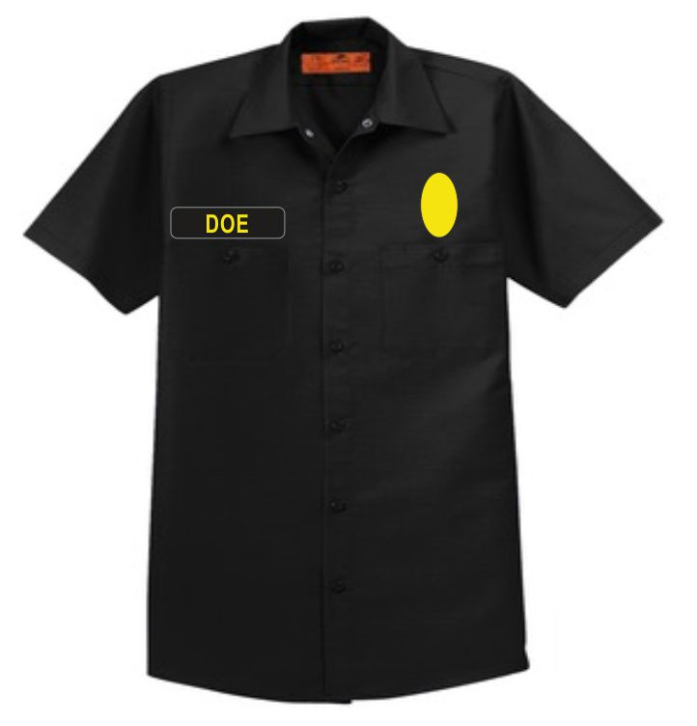

**Right Chest:** Name Strip with last name in Gold Block Lettering. Lettering will be ¾” tall; Namestrip is centered above pocket, 1” inch from bottom of patch.

**Left Chest:** OVAL patch badge Patch is 3 inches tall and 2 inches wide, patch is centered above pocket 1 inch from bottom of patch.

(every aspect of image above is for example or illustration ONLY)

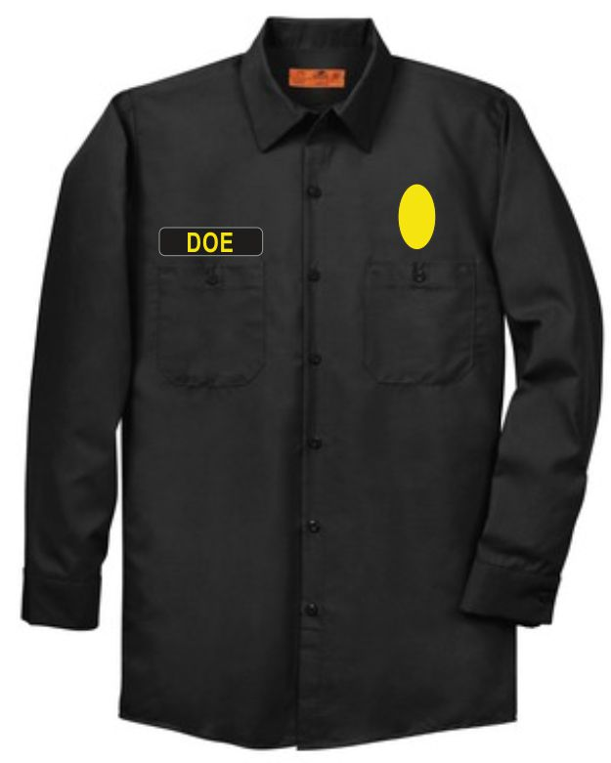

**Right Chest:** Name Strip with last name in Gold Block Lettering. Lettering will be ¾” tall; Namestrip is centered above pocket, 1” inch from bottom of patch.

**Left Chest:** OVAL patch badge Patch is 3 inches tall and 2 inches wide, patch is centered above pocket 1 inch from bottom of patch.

(every aspect of image above is for example or illustration ONLY)

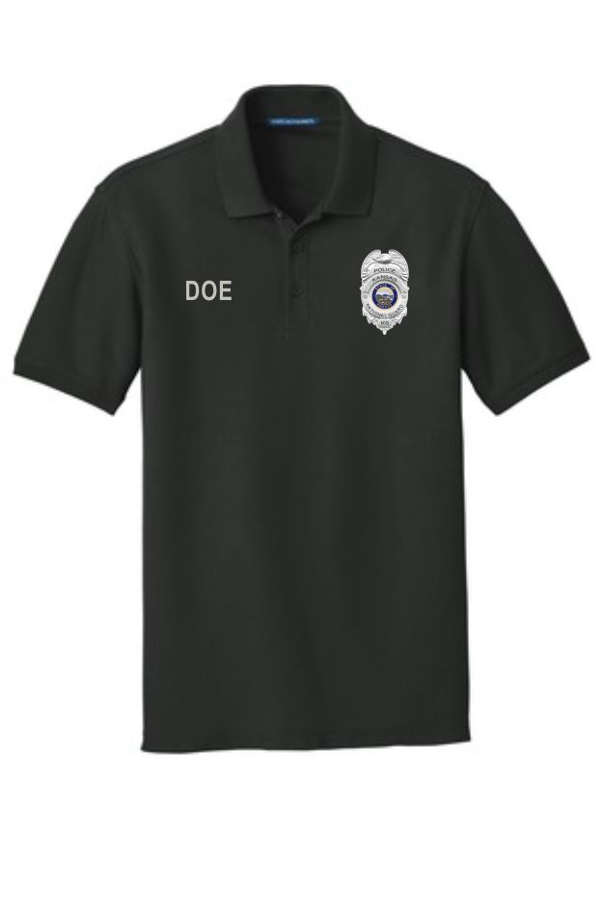

**Right Chest:** Rank and Last name Block Lettering ½ inch tall

**Left Chest:** Embroidered to fabric or Patch Badge 3 ½ inches tall and 2 ½ inches wide

(every aspect of image above is for example or illustration ONLY)

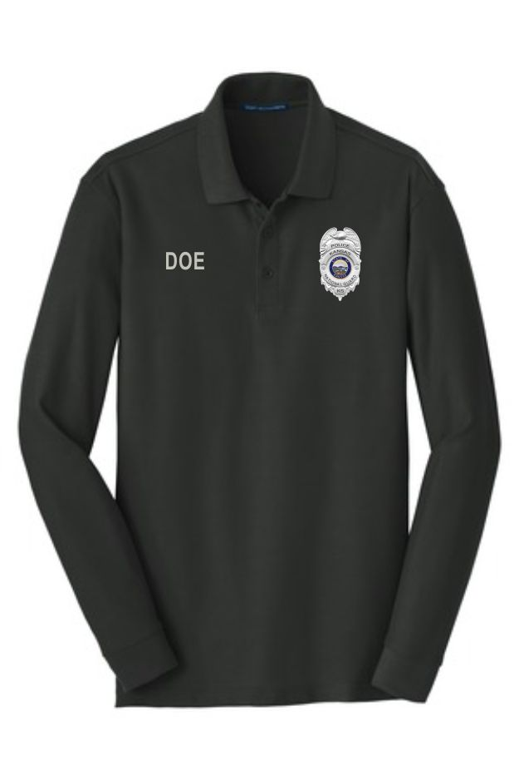

**Right Chest:** Rank and Last name Block Lettering ½ inch tall

**Left Chest:** Embroidered to fabric or Patch Badge 3 ½ inches tall and 2 ½ inches wide

(every aspect of image above is for example or illustration ONLY)

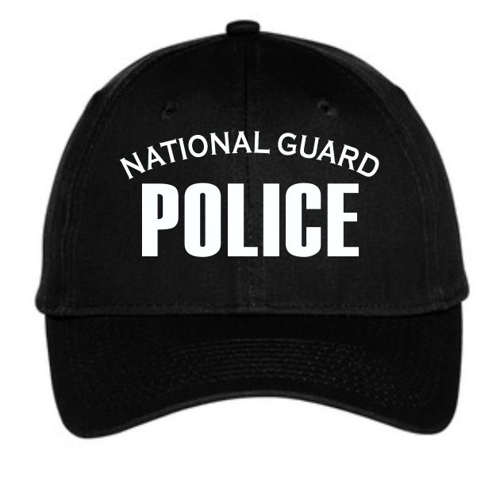

Black Ball Cap w/White Thread  
NATIONAL GUARD arched on top in Copperplate Gothic font  
POLICE centered below in Block letter font – Larger Bolder

(every aspect of image is for example or illustration ONLY)

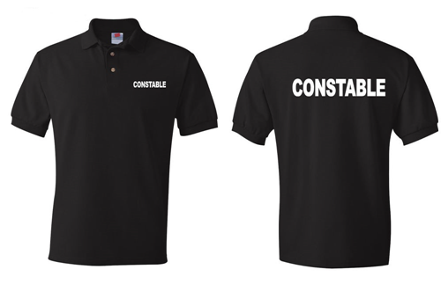

**Left Chest:** Rank and Last name Block Lettering ½ inch tall

**Across Back:** Embroidered to fabric or Silkscreen Block Lettering 3 ½ inches tall and 2 ½ inches wide

(every aspect of image above is for example or illustration ONLY)

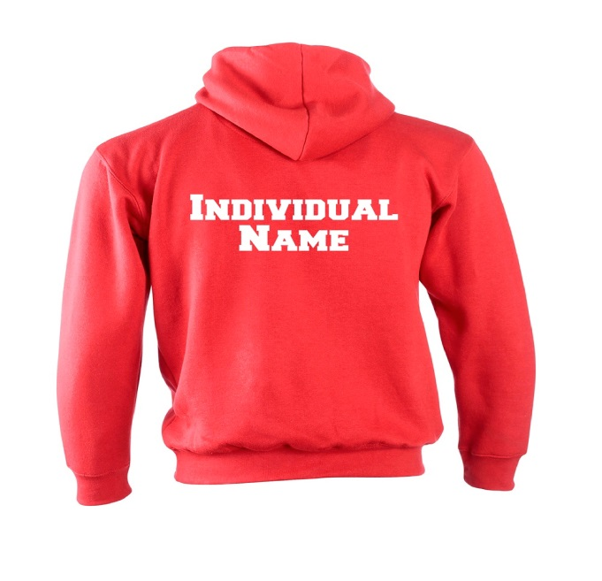

**Left Chest:** Rank and Last name Block Lettering ½ inch tall

**Across Back:** Embroidered to fabric or Silkscreen Block Lettering 3 ½ inches tall and 2 ½ inches wide

(every aspect of image above is for example or illustration ONLY)

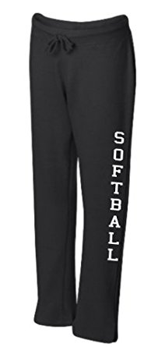

**DOWN LEG:** Embroidered to fabric or Silkscreen Block Lettering 3 ½ inches tall and 2 ½ inches wide

(every aspect of image above is for example or illustration ONLY)

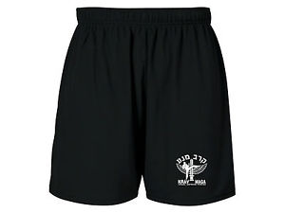

Silkscreen shorts

(every aspect of image above is for example or illustration ONLY)

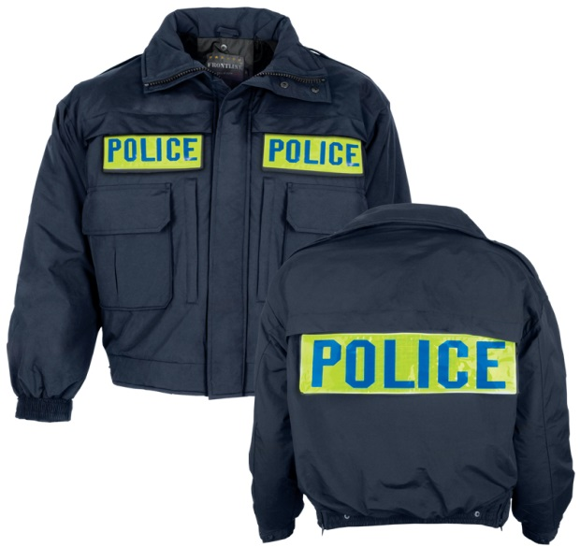

**Right Chest:** Name Strip / Name strip concealable

**Left Chest:** Name Strip / Name strip concealable

**Across Back:** Name Strip / Name strip concealable

(every aspect of image above is for example or illustration ONLY)