### Logo 3 color

### Company / Vendor Information

Company Name: __________________________ Company Phone: _________________

Company Address: ________________________________________________________

Contact Name: ___________________________Contact Phone: ___________________

Contact Email: ___________________________________________________________

Notes applicable to quotation: _______________________________________________

________________________________________________________________________

________________________________________________________________________

________________________________________________________________________

________________________________________________________________________

Fill in the above information and submit along with the completed 2025 Uniform Bid Form provided.

**Embroidery/Screen Print Information**

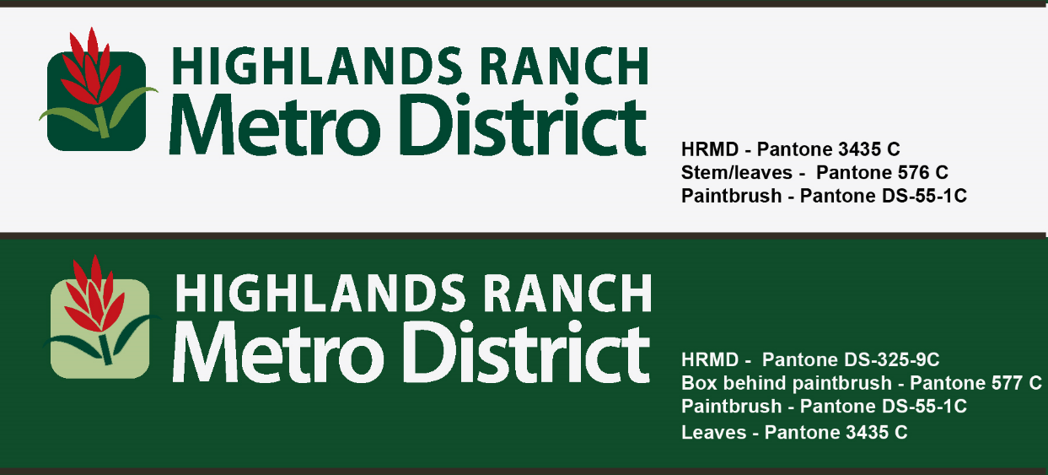

**Logo and colors for light and dark clothing items**