STATE PURCHASE-FY25-0062-SL

Attachment 1, Bleed Through Acceptability

Acceptable Sample of 90% Bleed Through:

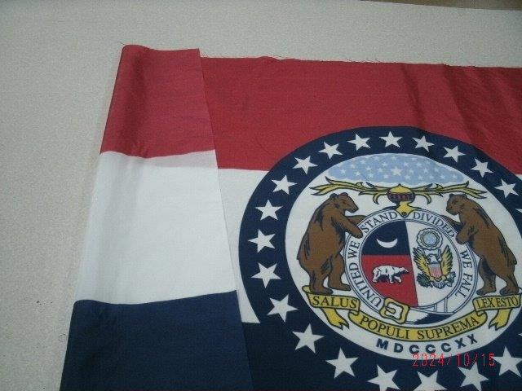

Unacceptable Sample of Bleed Through:

