Stretch Pullovers
Requesting for the ISP Museum Logo Store - 48 total Black Triblend "J. America" Omega Stretch Quarter Zip Pullovers in sizes: 8-Small, 8-Medium, 10-Large, 10-XL, 6-XXL, 6-XXXL; with 8 oz./yd², 51/43/6 rayon/polyester/elastane sueded heathered performance fabric, Four-way stretch fabric with striped loop back yarns, Set-in sleeves, Self-fabric collar, cuffs and waistband, Side seam pockets, Banded bottom. Requesting full color embroidered ISP Logo on upper left chest (attachment to show placement and size). Museum requires digital approval of logo placement before production run.
The J America type shirt is one that matches existing items and has been proven to meet our quality standards. If you wish to bid an alternate brand for this item, it can be considered but must closely match the style, color, and quality, of the J America offering.

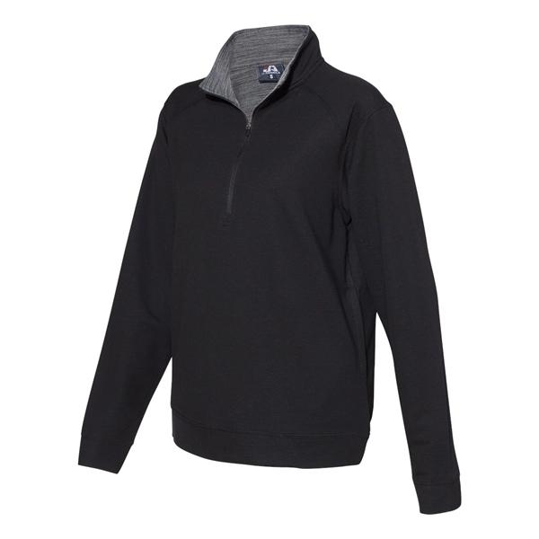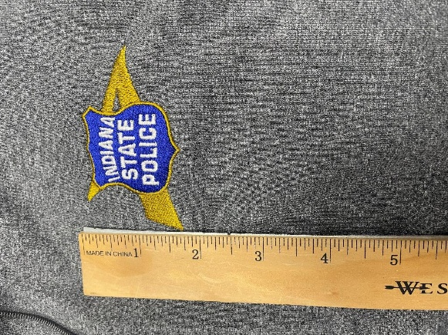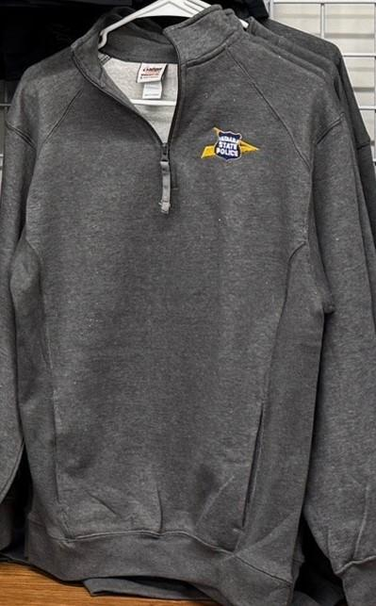
Fleece Sweatshirts
Requesting for the ISP Museum Logo Store - 48 total True Navy J. America Heavyweight Fleece Quarter-Zip Sweatshirts Quarter-Zip Fleece Pullovers in sizes: 7-Small, 10-Medium, 10-Large, 10-XL, 8-XXL, 3-XXXL; 9 oz./yd², 80/20 cotton/polyester fleece, Classic fit, 1x1 ribbed collar, Side gussets, Metal zipper, Welt pockets, 1x1 ribbed cuffs and bottom hem, Tear away label. Requesting full color embroidered ISP Logo on upper left chest (attachments to show placement and size). Museum requires digital approval of logo placement before production run.
The J America type shirt is one that matches existing items and has been proven to meet our quality standards. If you wish to bid an alternate brand for this item, it can be considered but must closely match the style, color, and quality, of the J America offering.
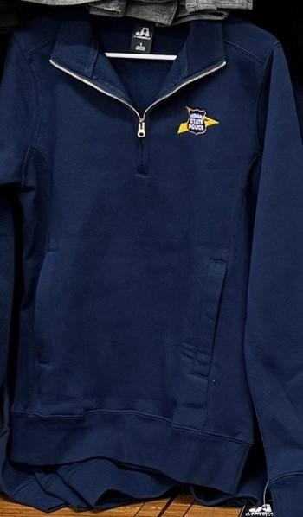

Fleece Pullovers
Requesting for the ISP Museum Logo Store - 48 total Charcoal 'Badger' Quarter-Zip Fleece Pullovers in sizes: 8-Small, 10-Medium, 12-Large, 10-XL, 6-XXL, 2-XXXL. 9.5 oz./yd², 60/40 ring-spun cotton/polyester, ¼ zip front with spandex reinforced 2x1 rib collar, cuffs waistband and side panels, Full hidden tunnel pocket with graphite color liner & headset opening, Contrast zipper, Embroidered Badger logo on left sleeve. Requesting full color embroidered ISP Logo on upper left chest (attachments to show placement and size). Museum requires digital approval of logo placement before production run.
The Badger type shirt is one that matches existing items and has been proven to meet our quality standards. If you wish to bid an alternate brand for this item, it can be considered but must closely match the style, color, and quality, of the Badger offering.

Additional Details
Please be sure to include any set up, design, or delivery fees in your quote. Additional costs added after the fact that are not detailed in your quote will not be paid. ISP does not have additional design documents/files beyond what is included here. However, we are able to provide a higher quality version of the ISP logo if necessary.

All items should be delivered to:
ISP Museum
8660 E 21st Street
Indianapolis, IN 46219

Inquiries into design details of these items being requested should be directed to JWampler2@isp.IN.gov

Inquiries into other aspects of this quote should be directed to CFiems@isp.IN.gov

