Exhibits 1 Through 11
Illinois State Toll Highway Authority

Product Descriptions

EXHIBIT 1
Male Tailored Work Shirts, Long Sleeve
(Reference Pricing Guidelines Group 1, Line 2)

Picture shown for emblem patches only.

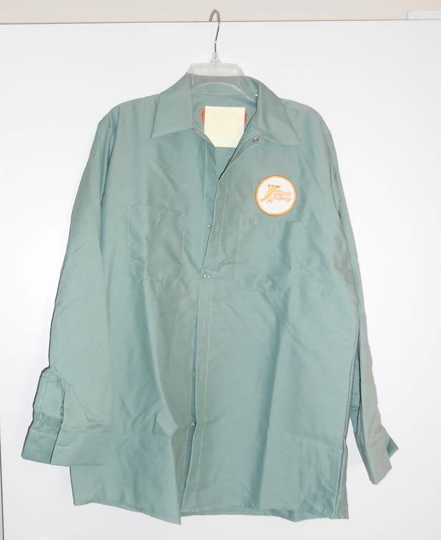

EXHIBIT 2
Male Polo Shirts, High-Visibility, Short Sleeve
(Reference Pricing Guidelines Group 2, Line 3)

Picture shown for embroidery logo only.
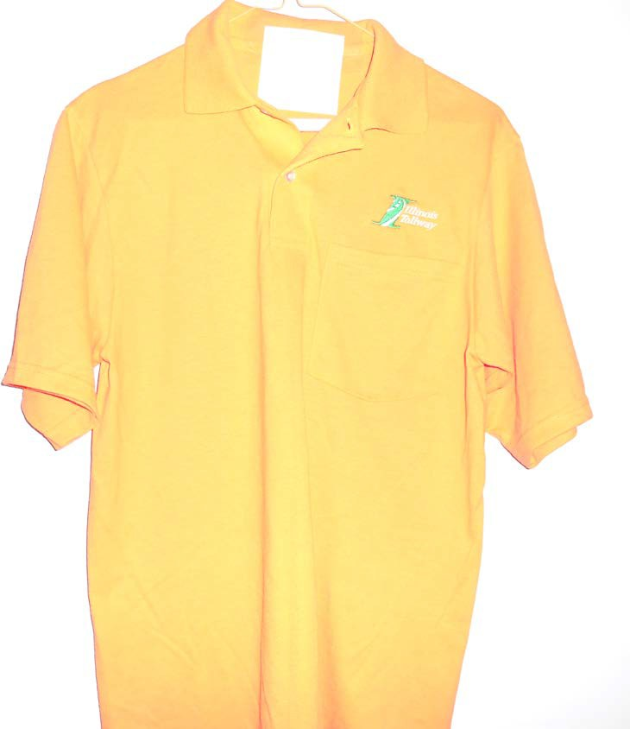

EXHIBIT 3
Male Tee Shirts, High-Visibility, Short and Long Sleeve
(Reference Pricing Guidelines Group 1, Line 6 and Line 7)

Picture shown for silk-screening logo only.
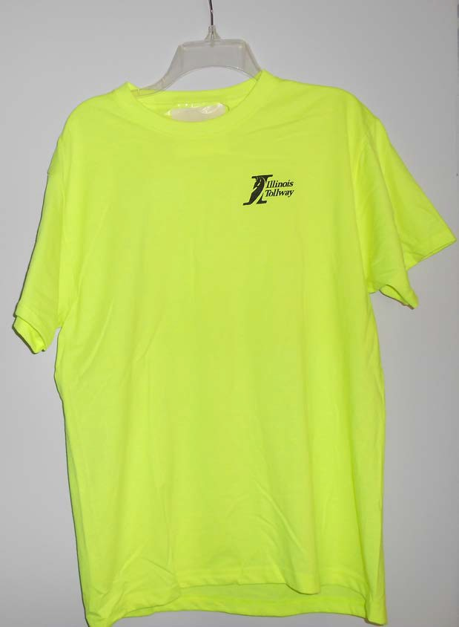

EXHIBIT 4

“H E L P” Shirts, High-Visibility, Short and Long Sleeve
(Reference Pricing Guidelines Group 1, Line 8 and Line 9)

Picture shown for required “H E LP” lettering and silk screening of insignia on left chest pocket in black.
Color shown should be High Visibility yellow/green, pictures shown for stripping only.

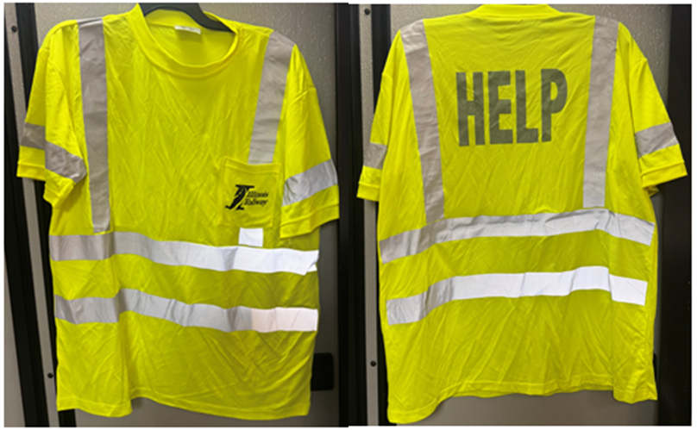

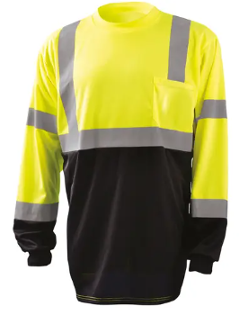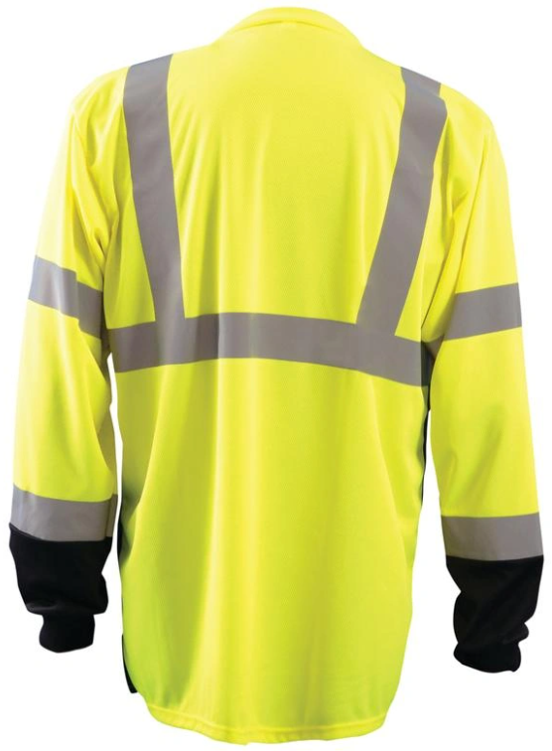
EXHIBIT 5
“H E L P” Jumpsuit
(Reference Pricing Guidelines Group 1, Line 22)

Color shown should be High Visibility yellow/green, picture shown for stripping only.
Picture shown for required “H E LP” lettering and patch placement on left chest.
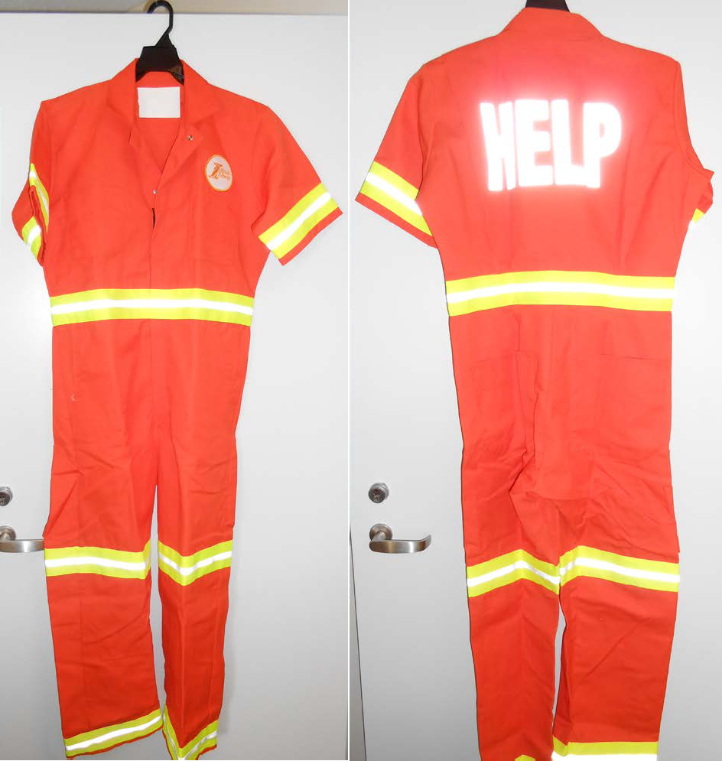

EXHIBIT 6
“H E L P” Parkas
(Reference Pricing Guidelines Group 1, Line 27)

Picture shown for required “H E L P” lettering and patch placement on left chest.
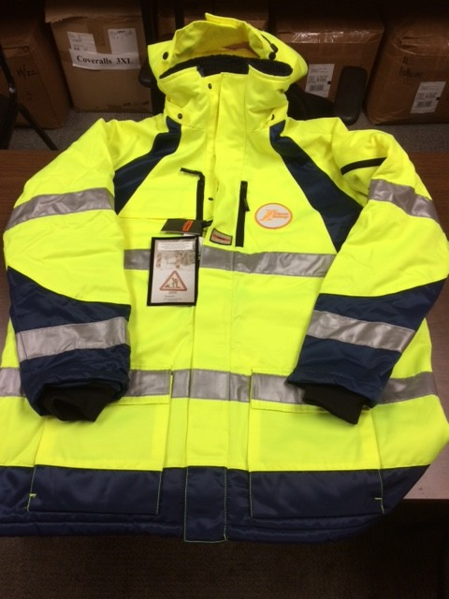
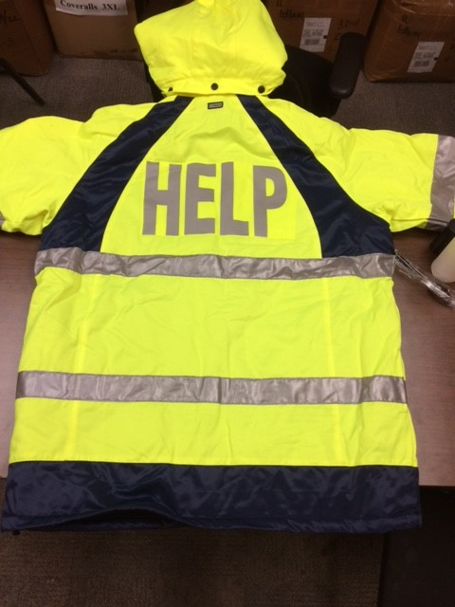

EXHIBIT 7
“H E L P” Hoodie
(Reference Pricing Guidelines Group 1, Line 33)

Color shown should be High Visibility Yellow / Black, picture shown for striping only.
Reference Exhibit 6 for the required “H E L P” lettering and patch placement on left chest.

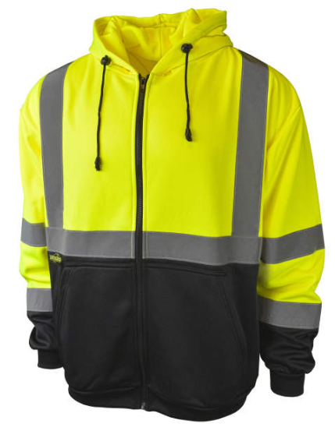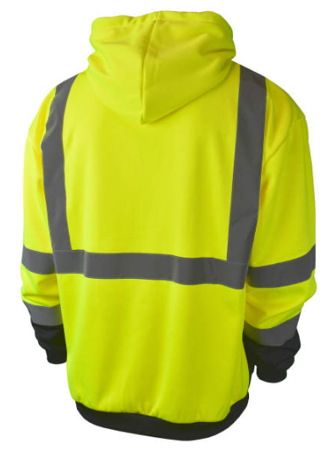
EXHIBIT 8
“H E L P” Overalls
(Reference Pricing Guidelines Group 1, Line 36)
Color shown should be High Visibility yellow/green, picture shown for striping only.
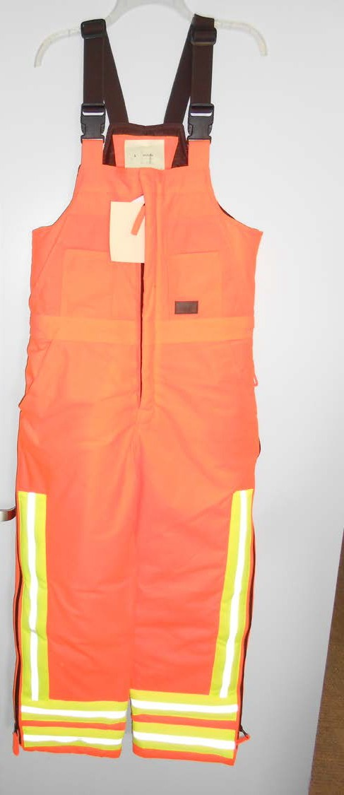

EXHIBIT 9
Mechanic High Visibility Short Sleeve T-Shirt
(Reference Pricing Guidelines Group 1, Line 10)

T-Shirt, Color shown should be High Visibility Black / Yellow, picture shown for striping only.
Reference Exhibit 3 for placement of silk-screening logo.
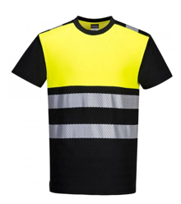

EXHIBIT 10
Mechanic High Visibility Button Down Short and Long Sleeve Shirts
(Reference Pricing Guidelines Group 1, Line 11 and Line 12)

Color shown should be High Visibility Fluorescent Yellow / Charcoal or High-visibility Fluorescent Yellow / Black, picture shown for striping only. Reference Exhibit 3 for placement of silk-screening logo.
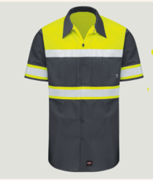

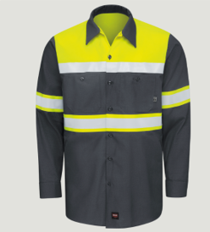

EXHIBIT 11
Mechanic Pant
(Reference Pricing Guidelines Group 1, Line 21)

Modern Fit Industrial Pant, Color shown should be Black. Inseam: hemmed and Unhemmed.

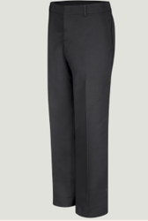

Exhibits 12
Illinois State Toll Highway Authority

Specification Compliance Questionnaire

EXHIBIT 12
Specification Compliance Questionnaire

The specifications outlined in this document are intended to ensure the Tollway receives garments that are suited for the task(s) they are being procured for. In many cases specifications vary between manufacturers and developing a single specification that provides adequate assurance to the Tollway of item capability, reliability and cost effectiveness may not recognize subtle differences that exist between manufacturers. The Tollway reserves the right to review each bidder’s proposal and determine if any specification differences have a significant impact on a specified item(s), capability, reliability or cost effectiveness at time of purchase or for the life of the item(s). The Tollway’s determination of contract specification compliance and acceptable specification deviations shall be final.

The bidder is required to complete and return with their bid the attached specification questionnaire and note any deviations from specifications for the line items listed in Group 1, Various Work Uniforms, Outerwear and Accessories, Group 2, Polo Shirts. Failure to return a completed specification questionnaire at the time of bid will deem the bid non-responsive.

The Bidder may use of the Pricing Specifications Guideline (Exhibit 13) to assist the Bidder with the completion of Specification Compliance Questionnaire (Exhibit 12).

Group 1 - Various Work Uniforms, Outerwear and Accessories

1._____YES ____NO IF NO, DETAIL_________________________
2._____YES ____NO IF NO, DETAIL_________________________
3._____YES ____NO IF NO, DETAIL_________________________
4._____YES ____NO IF NO, DETAIL_________________________
5._____YES ____NO IF NO, DETAIL_________________________
6._____YES ____NO IF NO, DETAIL_________________________
7._____YES ____NO IF NO, DETAIL_________________________
8._____YES ____NO IF NO, DETAIL_________________________
9._____YES ____NO IF NO, DETAIL_________________________
10.____YES ____NO IF NO, DETAIL_________________________
11. ____YES ____NO IF NO, DETAIL_________________________
12. ____YES ____NO IF NO, DETAIL_________________________
13. ____YES ____NO IF NO, DETAIL_________________________
14. ____YES ____NO IF NO, DETAIL_________________________
15. ____YES ____NO IF NO, DETAIL_________________________
16. ____YES ____NO IF NO, DETAIL_________________________
17. ____YES ____NO IF NO, DETAIL_________________________
18. ____YES ____NO IF NO, DETAIL_________________________
19. ____YES ____NO IF NO, DETAIL_________________________
20. ____YES ____NO IF NO, DETAIL_________________________
21. ____YES ____NO IF NO, DETAIL_________________________
22. ____YES ____NO IF NO, DETAIL_________________________
23. ____YES ____NO IF NO, DETAIL_________________________
24. ____YES ____NO IF NO, DETAIL_________________________
25. ____YES ____NO IF NO, DETAIL_________________________
26. ____YES ____NO IF NO, DETAIL_________________________.
27. ____YES ____NO IF NO, DETAIL_________________________
28. ____YES ____NO IF NO, DETAIL_________________________
29. ____YES ____NO IF NO, DETAIL_________________________
30. ____YES ____NO IF NO, DETAIL_________________________
31. ____YES ____NO IF NO, DETAIL_________________________
32. ____YES ____NO IF NO, DETAIL_________________________
33. ____YES ____NO IF NO, DETAIL_________________________
34. ____YES ____NO IF NO, DETAIL_________________________
35. ____YES ____NO IF NO, DETAIL_________________________
36. ____YES ____NO IF NO, DETAIL_________________________
37. ____YES ____NO IF NO, DETAIL_________________________
38. ____YES ____NO IF NO, DETAIL_________________________

Group 2 - Polo Shirts

1._____YES ____NO IF NO, DETAIL_________________________
2._____YES ____NO IF NO, DETAIL_________________________
3._____YES ____NO IF NO, DETAIL_________________________
4._____YES ____NO IF NO, DETAIL_________________________
5._____YES ____NO IF NO, DETAIL_________________________
6. _____YES ____NO IF NO, DETAIL_________________________
7._____YES ____NO IF NO, DETAIL_________________________
8. _____YES ____NO IF NO, DETAIL_________________________
9._____YES ____NO IF NO, DETAIL_________________________

Exhibits 13
Illinois State Toll Highway Authority

Pricing Specifications Guideline
EXHIBIT 13
Pricing Specifications Guideline
The use of the Pricing Specifications Guideline (Exhibit 13) is to assist the Bidder with the completion of Specification Compliance Questionnaire (Exhibit 12). Bidders are required to return with the bid the completed Pricing Specifications Guideline (Exhibit 13). DO NOT INCLUDE ANY PRICING. All Pricing shall be entered into BidBuy to be considered. Failure to return the questionnaire at the time of bid will deem the bid non-responsive.
Refer to BidBuy Items tab for all initial and renewal term pricing to be entered. Exhibit 13 lists only the Initial term and not the renewals.
For help with the Bulk Upload feature refer to the document “BidBuy Vendor Instructions: Export/Upload Items Feature.” for use on the BidBuy Item Tab. For Technical Difficulties reach out to the BidBuy Help Desk.
Group 1: Various Work Uniforms, Outerwear, and Accessories
Line # | Materials furnished under this contract shall be delivered in multiple deliveries as determined by the needs of the Tollway. The bid price shall be the delivered price for all items.
Line # | Description and Size | Estimated Quantity | Price/Each | Price Extension (Estimated Quantity x Price)
1 | Suspenders (See specifications in Section 1.2.3.1). (Carhardt SKU: A0005523 or approved equal)
1.1 | Size: One size fits all  Mfg: ____________________ Style:___________________ | 50 | All Pricing shall be entered into BidBuy to be considered.
2 | Shirt, male tailored work, long sleeve (See specifications in Sections 1.2.4.2). Exhibit 1
2.1 | Size: Men’s S through 2XL, sleeve length 33” through 35”  Mfg: ____________________ Style:___________________ | 150 | All Pricing shall be entered into BidBuy to be considered.
2.2 | Size: Men’s 3XL through 6XL, sleeve length 33” through 35”  Mfg: ____________________ Style:___________________ | 120 | All Pricing shall be entered into BidBuy to be considered.
2.3 | Size: Men’s Tall S through 2XL, sleeve length 35” through 39”  Mfg: ____________________ Style:___________________ | 120 | All Pricing shall be entered into BidBuy to be considered.
2.4 | Size: Men’s Tall 3XL through 6XL, sleeve length 35” through 39”  Mfg: ____________________ Style:___________________ | 80 | All Pricing shall be entered into BidBuy to be considered.
3 | Shirt, male tailored work, short sleeve (See specifications in Section 1.2.4.3).
3.1 | Size: Men’s S through 2XL  Mfg: ____________________ Style:___________________ | 300 | All Pricing shall be entered into BidBuy to be considered.
3.2 | Size: Men’s 3XL through 6XL  Mfg: ____________________ Style:___________________ | 50 | All Pricing shall be entered into BidBuy to be considered.
3.3 | Size: Men’s Tall S through 2XL  Mfg: ____________________ Style:___________________ | 350 | All Pricing shall be entered into BidBuy to be considered.
3.4 | Size: Men’s Tall 3XL through 6XL  Mfg: ____________________ Style:___________________ | 80 | All Pricing shall be entered into BidBuy to be considered.

Line # | Materials furnished under this contract shall be delivered in multiple deliveries as determined by the needs of the Tollway. The bid price shall be the delivered price for all items.
Line # | Description and Size | Estimated Quantity | Price/Each | Price Extension (Estimated Quantity x Price)
4 | Shirt, male, tailored long sleeve oxford dress (See specifications in Section 1.2.4.4).
4.1 | Size: Men’s S through 2XL, sleeve length 31” through 36”  Mfg: ____________________ Style:___________________ | 100 | All Pricing shall be entered into BidBuy to be considered.
4.2 | Size: Men’s 3XL through 4XL, sleeve length 31” through 36”  Mfg: ____________________ Style:___________________ | 100 | All Pricing shall be entered into BidBuy to be considered.
4.3 | Size: Men’s 5XL through 6XL, sleeve length 31” through 36”  Mfg: ____________________ Style:___________________ | 100 | All Pricing shall be entered into BidBuy to be considered.
4.4 | Size: Men’s Tall S through 2XL, sleeve length 31” through 38”  Mfg: ____________________ Style:___________________ | 100 | All Pricing shall be entered into BidBuy to be considered.
4.5 | Size: Men’s Tall 3XL through 6XL, sleeve length 31” through 38”  Mfg: ____________________ Style:___________________ | 100 | All Pricing shall be entered into BidBuy to be considered.
5 | Shirt, male, tailored short sleeve oxford dress (See specifications in Section 1.2.4.5).
5.1 | Size: Men’s S through 2XL  Mfg: ____________________ Style:___________________ | 100 | All Pricing shall be entered into BidBuy to be considered.
5.2 | Size: Men’s 3XL through 6XL  Mfg: ____________________ Style:___________________ | 100 | All Pricing shall be entered into BidBuy to be considered.
5.3 | Size: Men’s Tall S through 2XL  Mfg: ____________________ Style:___________________ | 100 | All Pricing shall be entered into BidBuy to be considered.
5.4 | Size: Men’s Tall 3XL through 6XL  Mfg: ____________________ Style:___________________ | 100 | All Pricing shall be entered into BidBuy to be considered.
6 | Tee shirt, short sleeve, Hi-vis Type R, Class 3 (See specifications in Section 1.2.4.6) Exhibit 3
6.1 | Size: Men’s S through 2XL  Mfg:____________________ Style:___________________ | 5000 | All Pricing shall be entered into BidBuy to be considered.
6.2 | Size: Men’s 3XL through 6XL  Mfg: ____________________ Style:___________________ | 1500 | All Pricing shall be entered into BidBuy to be considered.
7 | Tee shirt, long sleeve, Hi-vis Type R, Class 3 (See specifications in Section 1.2.4.7) Exhibit 3
7.1 | Size: Men’s S through 2XL  Mfg:____________________Style:_____________________ | 5000 | All Pricing shall be entered into BidBuy to be considered.
7.2 | Size: Men’s 3XL through 6XL  Mfg:____________________Style:_____________________ | 1500 | All Pricing shall be entered into BidBuy to be considered.
8 | Tee shirt, short sleeve, Hi-vis Type R, Class 3 “H E L P” Truck (See specifications in Section 1.2.4.8) Exhibit 4
8.1 | Size: Men’s S through 2XL  Mfg: ____________________ Style:___________________ | 450 | All Pricing shall be entered into BidBuy to be considered.
8.2 | Size: Men’s 3XL through 6XL  Mfg: ____________________ Style:___________________ | 100 | All Pricing shall be entered into BidBuy to be considered.

Line # | Materials furnished under this contract shall be delivered in multiple deliveries as determined by the needs of the Tollway. The bid price shall be the delivered price for all items.
Line # | Description and Size | Estimated Quantity | Price/Each | Price Extension (Estimated Quantity x Price)
9 | Tee shirt, Long sleeve, Hi-vis Type R, Class 3 “H E L P” Truck (See specifications in Section 1.2.4.9) Exhibit 4
9.1 | Size: Men’s S through 2XL  Mfg: ____________________ Style:___________________ | 450 | All Pricing shall be entered into BidBuy to be considered.
9.2 | Size: Men’s 3XL through 6XL  Mfg: ____________________ Style:___________________ | 100 | All Pricing shall be entered into BidBuy to be considered.
10 | Male Hi-Visibility Tee Shirts, Short Sleeve (See specifications in Section 1.2.4.10) (Portwest Pw311 or approved equal) Exhibit 9
10.1 | Size: Men’s S through 2XL  Mfg: ____________________ Style:___________________ | 500 | All Pricing shall be entered into BidBuy to be considered.
10.2 | Size: Men’s 3XL through 4XL  Mfg: ____________________ Style:___________________ | 150 | All Pricing shall be entered into BidBuy to be considered.
11 | Male Hi-Visibility Work Shirts, Short Sleeve (See specifications in Section 1.2.4.11) (Red Kap or Equal Brand) Exhibit 10
11.1 | Size: Men’s Regular, S through 2XL  Mfg: ____________________ Style:___________________ | 350 | All Pricing shall be entered into BidBuy to be considered.
11.2 | Size: Men’s Regular, 3XL through 4XL  Mfg: ____________________ Style:___________________ | 150 | All Pricing shall be entered into BidBuy to be considered.
11.3 | Size: Men’s Tall, S through 2XL  Mfg: ____________________ Style:___________________ | 350 | All Pricing shall be entered into BidBuy to be considered.
11.4 | Size: Men’s Tall, 3XL through 4XL  Mfg: ____________________ Style:___________________ | 150 | All Pricing shall be entered into BidBuy to be considered.
12 | Male Hi-Visibility Work Shirts, Long Sleeve (See specifications in Section 1.2.4.12) (Red Kap or Equal Brand) Exhibit 10
12.1 | Size: Men’s Regular, S through 2XL  Mfg: ____________________ Style:___________________ | 250 | All Pricing shall be entered into BidBuy to be considered.
12.2 | Size: Men’s Regular, 3XL through 4XL  Mfg: ____________________ Style:___________________ | 100 | All Pricing shall be entered into BidBuy to be considered.
12.3 | Size: Men’s Tall, S through 2XL  Mfg: ____________________ Style:___________________ | 250 | All Pricing shall be entered into BidBuy to be considered.
12.4 | Size: Men’s Tall, 3XL through 4XL  Mfg: ____________________ Style:___________________ | 100 | All Pricing shall be entered into BidBuy to be considered.
13 | Pants, male, work (See specifications in Section 1.2.5.1).
13.1 | Size: Men’s sizes 28 through 42, inseams from 25" through 38"  Mfg: ____________________ Style:___________________ | 1900 | All Pricing shall be entered into BidBuy to be considered.
13.2 | Size: Men’s sizes 44 through 56, inseams from 25" through 38"  Mfg: ____________________ Style:___________________ | 1500 | All Pricing shall be entered into BidBuy to be considered.
14 | Pants, female, work (See specifications in Section 1.2.5.2).
14.1 | Size: Women’s 4 through 20, inseams from 25" through 37"  Mfg: ____________________ Style:___________________ | 300 | All Pricing shall be entered into BidBuy to be considered.
14.2 | Size: Women’s 22 through 28, inseams from 25" through 37"  Mfg: ____________________ Style:___________________ | 300 | All Pricing shall be entered into BidBuy to be considered.

Line # | Materials furnished under this contract shall be delivered in multiple deliveries as determined by the needs of the Tollway. The bid price shall be the delivered price for all items.
Line # | Description and Size | Estimated Quantity | Price/Each | Price Extension (Estimated Quantity x Price)
15 | Pants, male, pleated (See specifications in Section 1.2.5.3).
15.1 | Size: Men’s 28 through 42, inseam 25” through 38”  Mfg: ____________________ Style:___________________ | 80 | All Pricing shall be entered into BidBuy to be considered.
15.2 | Size: Men’s 44 through 56, inseam 25” through 38”  Mfg: ____________________ Style:___________________ | 60 | All Pricing shall be entered into BidBuy to be considered.
16 | Pants, Cargo, Male (See specifications in Section 1.2.5.4).
16.1 | Size: Men’s 30 through 42, inseam 30”, 32”, and 34”  Mfg:____________________ Style:___________________ | 700 | All Pricing shall be entered into BidBuy to be considered.
16.2 | Size: Men’s 44 through 48, inseam 32” and 34”  Mfg:____________________ Style:___________________ | 700 | All Pricing shall be entered into BidBuy to be considered.
17 | Pants, Cargo, Female (See specifications in Section 1.2.5.4)
17.1 | Size: Women’s 4 through 20, inseam 25” through 36”  Mfg: ____________________ Style:___________________ | 200 | All Pricing shall be entered into BidBuy to be considered.
17.2 | Size: Women’s 22 through 28, inseam 25” through 36”  Mfg: ____________________ Style:___________________ | 150 | All Pricing shall be entered into BidBuy to be considered.
18 | Pants, Cargo, HELP Truck (See specifications in Section 1.2.5.5) (Red Kap PT88 or Dickies LP600 Industrial Relaxed fit or approved equal.)
18.1 | Size: Men’s 30 through 42, inseam 30”, 32”, 34”,36”, and unhemmed  Mfg: ____________________ Style:___________________ | 20 | All Pricing shall be entered into BidBuy to be considered.
18.2 | Size: Men’s 44 through 48, inseam 32”, 34”, 36”, and unhemmed  Mfg: ____________________ Style:___________________ | 10 | All Pricing shall be entered into BidBuy to be considered.
19 | Pants, painter (no bib) (See specifications in Section 1.2.5.6).
19.1 | Size: Men’s 28 through 42, inseam 30” through 38”  Mfg: ____________________ Style:___________________ | 150 | All Pricing shall be entered into BidBuy to be considered.
19.2 | Size: Men’s 44 through 48, inseam 30” through 38”  Mfg: ____________________ Style:___________________ | 50 | All Pricing shall be entered into BidBuy to be considered.
20 | Pants, pull-over, ANSI/ISEA 107-2020, Class E trouser (See specifications in Section 1.2.5.7).
20.1 | Size: S through XL  Mfg: ____________________ Style:___________________ | 150 | All Pricing shall be entered into BidBuy to be considered.
20.2 | Size: 2XL through 5XL  Mfg: ____________________ Style:___________________ | 150 | All Pricing shall be entered into BidBuy to be considered.
21 | Mechanic Industrial Pant (See specifications in Section 1.2.5.8). (Red Kap, PT22 or Equal Brand) Exhibit 11
21.1 | Size: Men’s 28 through 42, inseam 25” through 38”, and unhemmed  Mfg: ____________________ Style:___________________ | 400 | All Pricing shall be entered into BidBuy to be considered.
21.2 | Size: Men’s 44 through 56, inseam 25” through 38”, and unhemmed  Mfg: ____________________ Style:___________________ | 150 | All Pricing shall be entered into BidBuy to be considered.

Line # | Materials furnished under this contract shall be delivered in multiple deliveries as determined by the needs of the Tollway. The bid price shall be the delivered price for all items.
Line # | Description and Size | Estimated Quantity | Price/Each | Price Extension (Estimated Quantity x Price)
22 | Jumpsuit, full, high visibility, half-sleeved with elasticized waistband (See specifications in Section 1.2.6.1).  Type R, Class 3 Tollway Specific Requirement – Exhibit 5
22.1 | Size: Regular and Tall, S through 2XL  Mfg: ____________________ Style:___________________ | 150 | All Pricing shall be entered into BidBuy to be considered.
22.2 | Size: Regular and Tall, 3XL through 5XL  Mfg:____________________ Style:___________________ | 60 | All Pricing shall be entered into BidBuy to be considered.
23 | Jacket, men's, nylon windbreaker with cotton flannel lining (See specifications in Section 1.2.7.1).
23.1 | Size: Men’s XS through 2XL, center back length 28” to 32”  Mfg: ____________________ Style:___________________ | 1000 | All Pricing shall be entered into BidBuy to be considered.
23.2 | Size: Men’s 3XL through 4XL, center back length 33”  Mfg: ____________________ Style:___________________ | 800 | All Pricing shall be entered into BidBuy to be considered.
23.3 | Size: Men’s 5XL through 6XL, center back length 34” to 35”  Mfg: ____________________ Style:___________________ | 300 | All Pricing shall be entered into BidBuy to be considered.
24 | Jacket, bomber, polyester, with removable fleece liner Type R, Class 3 (See specifications in Section 1.2.7.2).
24.1 | Size: Men’s S through 2XL  Mfg: ____________________ Style:___________________ | 250 | All Pricing shall be entered into BidBuy to be considered.
24.2 | Size: Men’s 3XL through 5XL  Mfg: ____________________ Style:___________________ | 250 | All Pricing shall be entered into BidBuy to be considered.
24.3 | Size: Men’s tall, M through 2XL  Mfg: ____________________ Style:___________________ | 120 | All Pricing shall be entered into BidBuy to be considered.
24.4 | Size: Men’s tall, 3XL through 5XL  Mfg: ____________________ Style:___________________ | 150 | All Pricing shall be entered into BidBuy to be considered.
25 | Jacket, parka Type R, Class 3 (See specifications in Section 1.2.7.3).
25.1 | Size: Men’s S through 2XL  Mfg: ____________________ Style:___________________ | 150 | All Pricing shall be entered into BidBuy to be considered.
25.2 | Size: Men’s 3XL through 6XL  Mfg: ____________________ Style:___________________ | 150 | All Pricing shall be entered into BidBuy to be considered.
26 | Jacket, medium-weight, nylon with fleece lining and collar (See specifications in Section 1.2.7.4).
26.1 | Size: Men’s S through 2XL jacket length 25” to 28.5”  Mfg: ____________________ Style:___________________ | 1200 | All Pricing shall be entered into BidBuy to be considered.
26.2 | Size: Men’s 3XL through 4XL jacket length 29” to 29.5”  Mfg: ____________________ Style:___________________ | 500 | All Pricing shall be entered into BidBuy to be considered.
26.3 | Size: Men’s 5XL through 6XL jacket length 30” to 30.5”  Mfg: ____________________ Style:___________________ | 200 | All Pricing shall be entered into BidBuy to be considered.
27 | Parka, winter, shell, 100% acrylic (See specifications in Section 1.2.7.5).  Type R, Class 3 Tollway Specific Requirement – Exhibit 6
27.1 | Size: Men’s Regular and Tall, S through 2XL  Mfg: ____________________ Style:___________________ | 60 | All Pricing shall be entered into BidBuy to be considered.
27.2 | Size: Men’s Regular and Tall, 3XL through 5XL  Mfg: ____________________ Style:___________________ | 60 | All Pricing shall be entered into BidBuy to be considered.

Line # | Materials furnished under this contract shall be delivered in multiple deliveries as determined by the needs of the Tollway. The bid price shall be the delivered price for all items.
Line # | Description and Size | Estimated Quantity | Price/Each | Price Extension (Estimated Quantity x Price)
28 | Hood, insulated, detachable, for insulated parka. May be ordered with Lines 25.1, 25.2, 27.1, and 27.2. (See specifications in Section 1.2.7.6).
28.1 | Size: One size  Mfg: ____________________ Style:___________________ | 100 | All Pricing shall be entered into BidBuy to be considered.
29 | Jacket, Soft shell Type R, Class 3 (See specifications in Section 1.2.7.7).
29.1 | Size: Men’s Regular, S through 2XL  Mfg: ____________________ Style:___________________ | 30 | All Pricing shall be entered into BidBuy to be considered.
29.2 | Size: Men’s Regular, 3XL through 5XL  Mfg: ____________________ Style:___________________ | 20 | All Pricing shall be entered into BidBuy to be considered.
29.3 | Size: Men’s Tall, S through 2XL  Mfg: ____________________ Style:___________________ | 30 | All Pricing shall be entered into BidBuy to be considered.
29.4 | Size: Men’s Tall, 3XL through 5XL  Mfg: ____________________ Style:___________________ | 20 | All Pricing shall be entered into BidBuy to be considered.
30 | Fleece Jacket Full Zip Front, (Port Authority SKU: F217 or Equal Brand) (See specifications in Section 1.2.7.8).
30.1 | Size: Regular, S through 2XL  Mfg: ____________________ Style:___________________ | 50 | All Pricing shall be entered into BidBuy to be considered.
30.2 | Size: Regular, 3XL through 5XL  Mfg: ____________________ Style:___________________ | 30 | All Pricing shall be entered into BidBuy to be considered.
30.3 | Size: Tall, S through 2XL  Mfg: ____________________ Style:___________________ | 50 | All Pricing shall be entered into BidBuy to be considered.
30.4 | Size: Tall, 3XL through 5XL  Mfg: ____________________ Style:___________________ | 30 | All Pricing shall be entered into BidBuy to be considered.
31 | Fleece 1/4-Zip Front Pullover (Port Authority SKU: F295 or Equal Brand) (See specifications in Section 1.2.7.9)
31.1 | Size: Regular, S through 2XL  Mfg: ____________________ Style:___________________ | 60 | All Pricing shall be entered into BidBuy to be considered.
31.2 | Size: Regular, 3XL through 5XL  Mfg: ____________________ Style:___________________ | 60 | All Pricing shall be entered into BidBuy to be considered.
31.3 | Size: Tall, S through 2XL  Mfg: ____________________ Style:___________________ | 30 | All Pricing shall be entered into BidBuy to be considered.
31.4 | Size: Tall, 3XL through 5XL  Mfg: ____________________ Style:___________________ | 30 | All Pricing shall be entered into BidBuy to be considered.
32 | Hoodie, Type R, Class 3 (See specifications in Section 1.2.7.10).
32.1 | Size: Men’s Regular, S through 2XL  Mfg: ____________________ Style:___________________ | 160 | All Pricing shall be entered into BidBuy to be considered.
32.2 | Size: Men’s Regular, 3XL through 4XL  Mfg: ____________________ Style:___________________ | 80 | All Pricing shall be entered into BidBuy to be considered.
32.3 | Size: Men’s Regular, 5XL through 6XL  Mfg: ____________________ Style:___________________ | 50 | All Pricing shall be entered into BidBuy to be considered.
32.4 | Size: Men’s Tall, S through 2XL  Mfg: ____________________ Style:___________________ | 80 | All Pricing shall be entered into BidBuy to be considered.

Line # | Materials furnished under this contract shall be delivered in multiple deliveries as determined by the needs of the Tollway. The bid price shall be the delivered price for all items.
Line # | Description and Size | Estimated Quantity | Price/Each | Price Extension (Estimated Quantity x Price)
32 | Hoodie, Type R, Class 3 (See specifications in Section 1.2.7.10).
32.5 | Size: Men’s Tall, 3XL through 4XL  Mfg: ____________________ Style:___________________ | 60 | All Pricing shall be entered into BidBuy to be considered.
32.6 | Size: Men’s Tall, 5XL through 6XL  Mfg: ____________________ Style:___________________ | 50 | All Pricing shall be entered into BidBuy to be considered.
33 | “H E L P” Hoodie, Type R, Class 3 (See specifications in Section 1.2.7.11). Exhibit 7
33.1 | Size: Men’s Regular, S through 2XL  Mfg: ____________________ Style:___________________ | 20 | All Pricing shall be entered into BidBuy to be considered.
33.2 | Size: Men’s Regular, 3XL through 4XL  Mfg: ____________________ Style:___________________ | 40 | All Pricing shall be entered into BidBuy to be considered.
33.3 | Size: Men’s Regular, 5XL through 6XL  Mfg: ____________________ Style:___________________ | 40 | All Pricing shall be entered into BidBuy to be considered.
33.4 | Size: Men’s Tall, S through 2XL  Mfg: ____________________ Style:___________________ | 20 | All Pricing shall be entered into BidBuy to be considered.
33.5 | Size: Men’s Tall, 3XL through 4XL  Mfg: ____________________ Style:___________________ | 40 | All Pricing shall be entered into BidBuy to be considered.
33.6 | Size: Men’s Tall, 5XL through 6XL  Mfg: ____________________ Style:___________________ | 40 | All Pricing shall be entered into BidBuy to be considered.
34 | Sweater, acrylic (See specification in Section 1.2.8).
34.1 | Size: Men’s S through 2XL  Mfg: ____________________ Style:___________________ | 50 | All Pricing shall be entered into BidBuy to be considered.
34.2 | Size: Men’s 3XL through 5XL  Mfg: ____________________ Style:___________________ | 50 | All Pricing shall be entered into BidBuy to be considered.
35 | Sweatshirt, hooded (See specifications in Section 1.2.9).
35.1 | Size: Men’s S through 2XL  Mfg: ____________________ Style:___________________ | 160 | All Pricing shall be entered into BidBuy to be considered.
35.2 | Size: Men’s 3XL through 4XL  Mfg: ____________________ Style:___________________ | 50 | All Pricing shall be entered into BidBuy to be considered.
35.3 | Size: Men’s 5XL through 6XL  Mfg: ____________________ Style:___________________ | 80 | All Pricing shall be entered into BidBuy to be considered.
35.4 | Size: Men’s Tall, M through 2XL  Mfg: ____________________ Style:___________________ | 60 | All Pricing shall be entered into BidBuy to be considered.
35.5 | Size: Men’s Tall, 3XL through 4XL  Mfg: ____________________ Style:___________________ | 30 | All Pricing shall be entered into BidBuy to be considered.
35.6 | Size: Men’s Tall, 5XL through 6XL  Mfg: ____________________ Style:___________________ | 60 | All Pricing shall be entered into BidBuy to be considered.
Line # | Materials furnished under this contract shall be delivered in multiple deliveries as determined by the needs of the Tollway. The bid price shall be the delivered price for all items.
Line # | Description and Size | Estimated Quantity | Price/Each | Price Extension (Estimated Quantity x Price)
36 | Overall, bib-type insulated, to match parka (See specifications in Section 1.2.10).  Tollway Specific Requirement – Exhibit 8
36.1 | Size: Men’s Regular and Tall, S through 2XL  Mfg: ____________________ Style:___________________ | 100 | All Pricing shall be entered into BidBuy to be considered.
36.2 | Size: Men’s Regular and Tall, 3XL through 5XL  Mfg: ____________________ Style:___________________ | 100 | All Pricing shall be entered into BidBuy to be considered.
37 | Charge, custom lengths. (See specifications in Section 1.2.11)
37.1 | There shall be an additional charge allowed for extra length on sleeves, waists, pants and hems up to size 6XL, outside of the specifications listed in the sections above for Various Work Uniforms, Outerwear, Accessories, (GROUP 1). | 1 | All Pricing shall be entered into BidBuy to be considered.
38 | Charge, custom lengths. (See specifications in Section 1.2.12)
38.1 | There shall be an additional charge allowed for customization for sizes greater than 6XL, outside of the specifications listed in the sections above for Various Work Uniforms, Outerwear, Accessories, (GROUP 1) | 1 | All Pricing shall be entered into BidBuy to be considered.
Group 2 Uniforms - Polo Shirts, Performance Knit, Enhanced Visibility
Line # | Materials furnished under this contract shall be delivered in multiple deliveries as determined by the needs of the Tollway. The bid price shall be the delivered price for all items.
Line # | Description and Size | Estimated Quantity | Price/Each | Price Extension (Estimated Quantity x Price)
1 | Polo shirt, short sleeve (See specifications in Section 1.2.13.1).
1.1 | Size: Men’s Regular sizes S through XL  Mfg: ____________________ Style:___________________ | 600 | All Pricing shall be entered into BidBuy to be considered.
1.2 | Size: Men’s Regular sizes 2XL through 3XL  Mfg: ____________________ Style:___________________ | 600 | All Pricing shall be entered into BidBuy to be considered.
1.3 | Size: Men’s Regular sizes 4XL through 5XL  Mfg: ____________________ Style:___________________ | 100 | All Pricing shall be entered into BidBuy to be considered.
2 | Polo shirt, long sleeve (See specifications in Section 1.2.13.2).
2.1 | Size: Men’s Regular sizes S through XL  Mfg: ____________________ Style:___________________ | 600 | All Pricing shall be entered into BidBuy to be considered.
2.2 | Size: Men’s Regular sizes 2XL through 3XL  Mfg: ____________________ Style:___________________ | 600 | All Pricing shall be entered into BidBuy to be considered.
2.3 | Size: Men’s Regular sizes 4XL through 5XL  Mfg: ____________________ Style:___________________ | 100 | All Pricing shall be entered into BidBuy to be considered.
3 | Polo shirt, short sleeve Performance Knit (Red Kap SK02 or Equal Brand) (See specifications in Section 1.2.13.3). Exhibit 2
3.1 | Size: Men’s Regular sizes S through 2XL  Mfg: ____________________ Style:___________________ | 150 | All Pricing shall be entered into BidBuy to be considered.

Line # | Materials furnished under this contract shall be delivered in multiple deliveries as determined by the needs of the Tollway. The bid price shall be the delivered price for all items.
Line # | Description and Size | Estimated Quantity | Price/Each | Price Extension (Estimated Quantity x Price)
3 | Polo shirt, short sleeve Performance Knit (Red Kap SK02 or Equal Brand) (See specifications in Section 1.2.13.3). Exhibit 2
3.2 | Size: Men’s Regular sizes 3XL through 5XL  Mfg: ____________________ Style:___________________ | 100 | All Pricing shall be entered into BidBuy to be considered.
4 | Polo shirt, long sleeve Performance Knit (Red Kap SK02 or Equal Brand) (See specifications in Section 1.2.13.4).
4.1 | Size: Men’s Regular sizes S through 2XL  Mfg: ____________________ Style:___________________ | 150 | All Pricing shall be entered into BidBuy to be considered.
4.2 | Size: Men’s Regular sizes 3XL through 5XL  Mfg: ____________________ Style:___________________ | 150 | All Pricing shall be entered into BidBuy to be considered.
5 | Short Sleeve, (Port Authority SKU: K525 or Equal Brand) (See specifications in Section 1.2.13.5).
5.1 | Size: Men’s Regular sizes S through 2XL  Mfg: ____________________ Style:___________________ | 60 | All Pricing shall be entered into BidBuy to be considered.
5.2 | Size: Men’s Regular sizes 3XL through 5XL  Mfg: ____________________ Style:___________________ | 60 | All Pricing shall be entered into BidBuy to be considered.
5.3 | Size: Men’s Tall sizes S through 2XL  Mfg: ____________________ Style:___________________ | 60 | All Pricing shall be entered into BidBuy to be considered.
5.4 | Size: Men’s Tall sizes 3XL through 5XL  Mfg: ____________________ Style:___________________ | 60 | All Pricing shall be entered into BidBuy to be considered.
6 | Long Sleeve, (Port Authority SKU: K455LS or Equal Brand) (See specifications in Section 1.2.13.6).
6.1 | Size: Men’s Regular sizes S through 2XL  Mfg: ____________________ Style:___________________ | 60 | All Pricing shall be entered into BidBuy to be considered.
6.2 | Size: Men’s Regular sizes 3XL through 5XL  Mfg: ____________________ Style:___________________ | 60 | All Pricing shall be entered into BidBuy to be considered.
6.3 | Size: Men’s Tall sizes S through 2XL  Mfg: ____________________ Style:___________________ | 60 | All Pricing shall be entered into BidBuy to be considered.
6.4 | Size: Men’s Tall sizes 3XL through 5XL  Mfg: ____________________ Style:___________________ | 60 | All Pricing shall be entered into BidBuy to be considered.
7 | Polo shirt, Short Sleeve Enhanced Visibility (Blaklader SKU: 346810518933 or approved equal.) (See specifications in Section 1.2.13.7).
7.1 | Size: Men’s Regular sizes S through 2XL  Mfg: ____________________ Style:___________________ | 50 | All Pricing shall be entered into BidBuy to be considered.
7.2 | Size: Men’s Regular sizes 3XL through 5XL  Mfg: ____________________ Style:___________________ | 50 | All Pricing shall be entered into BidBuy to be considered.
8 | Charge, custom lengths. (See specifications in Section 1.2.14)
8.1 | There shall be an additional charge allowed for extra length on sleeves, waists, outside of the specifications listed in the sections above for 1.2.13 Polos, (Group 2). | 1 | All Pricing shall be entered into BidBuy to be considered.
9 | Charge, custom lengths. (See specifications in Section 1.2.15)
9.1 | There shall be an additional charge allowed for customization for sizes greater than 5XL, outside of the specifications listed in the sections above for Various Work Uniforms, Outerwear, Accessories, (GROUP 1) | 1 | All Pricing shall be entered into BidBuy to be considered.

