
The Ohio Department of Natural Resources is requesting bids for: A Division of Parks and Watercraft Natural Resources Officer mascot costume.
Name or Title of the Service or Supply: Division of Parks and Watercraft, Natural Resources Officer mascot costume.
Ordering Division and address: 2045 Morse Rd., Columbus, Ohio 43229
Specifications:
Officer Foxwood is the new Natural Resources Officer Mascot. The inspiration came from a student mascot drawing contest, and the name was chosen by visitors at The Ohio State Fair. Ohio State Parks & Watercraft would like to bring this character to life with a full mascot costume. The mascot will appear at a number of public events. Target audiences will be primarily families and children, but Officer Foxwood will be an honorary officer appearing at many park and agency events.
The costume should be flexible, allowing Officer Foxwood to be attentive to his duties and capable of moving with a range of motion. For instance, we may require the mascot to move in and out of vehicles, hike trails, patrol, etc. We are interested in seeing your ideas to help us bring this lovable character to life. This is our vision, but we know you are experts and can help us make this character a reality. Submissions can and should note any non-viable aspects of our vision and provide applicable substitutions or solutions if relevant.
GENERAL SPECIFICATIONS:
- Flexible, allows for the mascot to be active
- Able to see well within the costume - and not have to be guided by staff. We understand there will likely be some limitations, but we would like Officer Foxwood to be as independent as possible.
- Breathable, lightweight (cool for summer outdoor use)
- Durable
- Water resistant/able to withstand outdoor elements (many park events throughout the year have a wide range of weather conditions)
- Provide/Outline cleaning/dry cleaning procedures recommended for the approach/solution?

FEATURES:
Full Head with a Campaign Hat
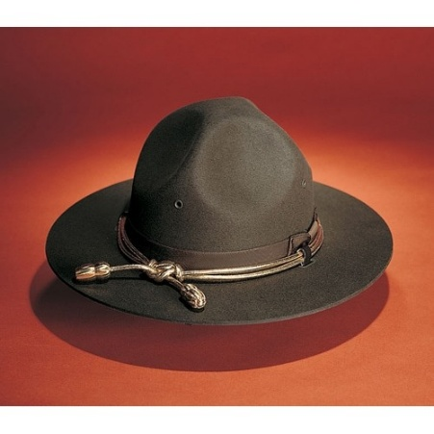
Upper Body/Torso
- Long sleeve and short-sleeve versions (mascot would wear the standard issued jackets)
- Duty Belt to accompany (to include a representational but not fully identifiable firearm)
- Must include a Personal Flotation Device (lifejacket) for intermittent use in boating education events/opportunities.
- External carrier (oversized – to fit over the coat)
- Summer- furry arm plus glove/Cold weather long sleeve/jacket with gloved hand
Lower Body
- Tail must be included somewhere; maybe tie into duty belt? Must be secure.
- Standard Uniform Pant
- Standard boots for footwear
Proposals must include two previous examples of a project of a similar scope you have completed, along with a detailed proposal of how your company would create and execute a costume for Officer Foxwood. Two or three approaches/materials/styles and price tiers would be ideal for consideration.
Please provide the necessary guidelines/best practices/budget requirements for cleaning and maintaining the costume.
We also recognize that the costume may require that the execution be completed in phases. Please make your recommendations based on your expertise. Ohio State Parks and Watercraft is open to discussing the ideal production and delivery timeline to make a successful execution.

Please reach out through the OhioBuys portal if any additional clarifications are required on the project. We will host a bidders meeting prior to the deadline to help answer questions, as well as discuss how our mascot will be strategically implemented into activities and programs.

Artistic rendering of the mascot:
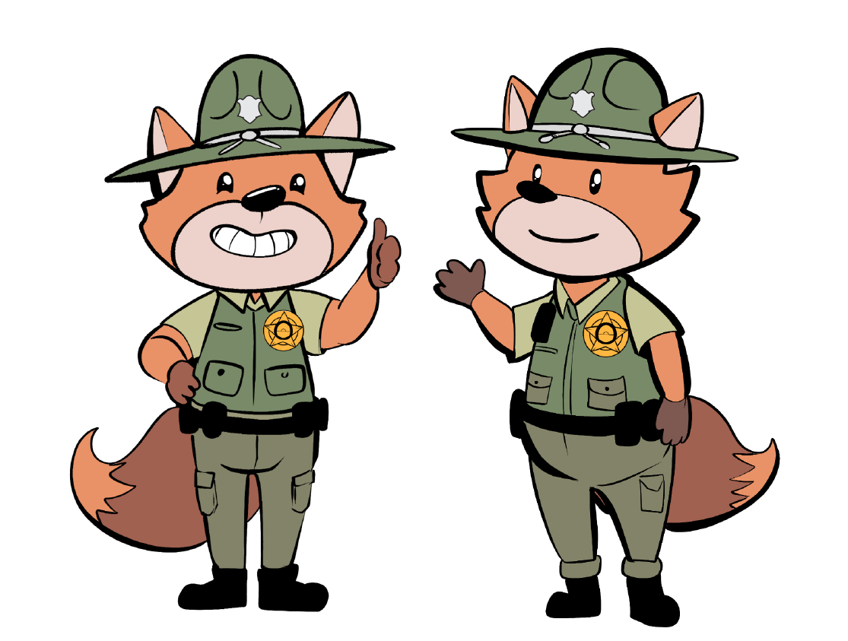

Examples of mascots of a similar quality desired:

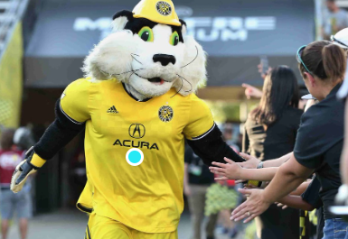
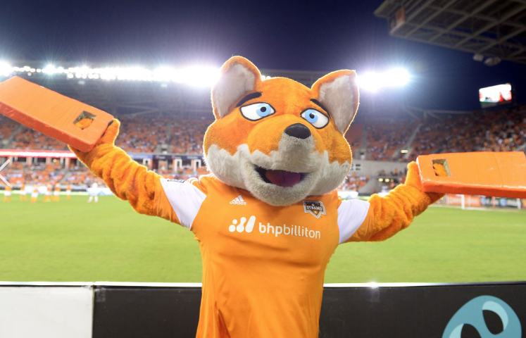
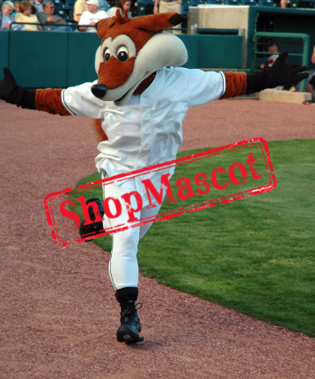
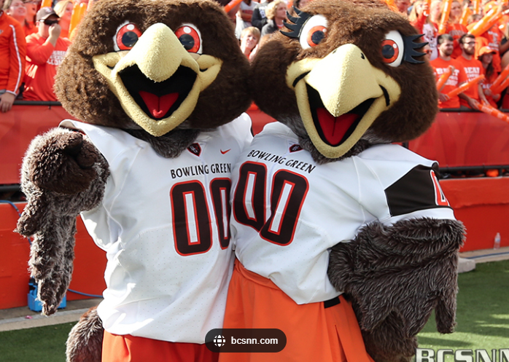
Completion Date: (completion within three months after awarded)
Delivery:
Ohio State Parks and Watercraft
2045 Morse Rd.,
Columbus, Ohio 43229

Attn: Kristin Wallschlaeger
Phone: 614-307-6300
Email: kristin.wallschlaeger@dnr.ohio.gov

F.O.B. DESTINATION/PRE-PAID/ALLOWED. The Contractor must provide Deliverables under this Contract F.O.B. Destination/Pre-Paid/Allowed. The place of destination will be specified by the Ordering Agency on the agency’s purchase order or other ordering document. Cost of the freight must be borne and paid by the Contractor unless otherwise stated.
All risk of loss, regardless of the cause, will remain with the Contractor until title to the Deliverable passes to the State. Unless otherwise provided in this Contract, the State will determine whether the Contractor provided each Deliverable required in this Contract and has fully met all work requirements of this Contract. Title to any Deliverables will pass to the State on Acceptance of the Deliverable.
Evaluation The contract will be awarded to the lowest responsive and responsible bidder as determined by the State.
Contract Award. The contract will be awarded to the lowest responsive and responsible bidder by line item.

Bill to information:
Invoicing
Invoices Origin-DNR-V29 (A unique number will be provided with each invoice.)

All invoices must be submitted DIRECTLY to Ohio Shared Services (OSS).
There are three options available to submit invoices to OSS:
- EMAIL the invoice to: invoices@ohio.gov
- FAX the invoice to: 1-614-485-1039
- MAIL the invoice to: Ohio Shared Services, PO Box 182880, Columbus, Ohio 43218-2880
In order to process your invoice, please make sure all the required information listed below is on your invoice before submitting it to OSS or they will be returned for not being a proper invoice.
- Must include the Purchase Order (PO) number assigned. You may shorten it to the last five digits.
- Supplier full name as it appears on your PO.
- The Ship to and/or service facility name and full address
- Unique invoice number
- Date of service or date work was completed.
- Complete itemization of services performed, materials or goods supplied and/or labor furnished.
- Line charge(s). If parts are included, please break out the line charges with product and charges separately.
- No State of Ohio sales tax
- Remit to address must match our records for payment
- This PO is only valid for the goods and/or services received through June 30, 2026.
- Any goods/services received after June 30, 2026, will require a new PO.
All fields mentioned above are required to count as a correct invoice; failure to provide this information will result in a returned invoice and delayed payment.
Contract Negotiations. Negotiations will be scheduled at the convenience of DNR. The selected Offeror(s) are expected to negotiate in good faith.

