

UPST BID #, NAME: Click or tap here to enter text., Click or tap here to enter text.
UMASS CAMPUS, DEPARTMENT: Click or tap here to enter text., Click or tap here to enter text.

CFS - ATTACHMENT B – TRADEMARK LICENSE ADDENDUM
Consisting of Click or tap here to enter text. pages
Contract No. Click or tap here to enter text.
This Trademark License Addendum (“Addendum”) is made this day, Click or tap here to enter text., by and between the University of Massachusetts by and through its Trademark and License Administration (“Licensor”) and Click or tap here to enter text. (“Contractor”) (collectively the “Parties”), and supplements the Click or tap here to enter text. Contract between the University of Massachusetts and Contractor (the “Contract”). All terms and conditions of the Contract are hereby incorporated by reference.
WHEREAS, Licensor is the owner of the Licensed Mark (as set forth in Schedule 1) and is willing to grant to Contractor a license to use the Licensed Mark in accordance with the terms and conditions set forth in this Addendum and the Contract; and
WHEREAS, Contractor wishes to use the Licensed Mark in connection with services described in the Contract and any associated Scope of Services/Scope of Work (“Licensed Services”).
- License Grant.
Subject to this Addendum and the Contract terms and conditions, Licensor hereby grants to Contractor during the Term of the Contract a non-exclusive, non-transferable, non-sublicenseable license to use the Licensed Mark in connection with the Licensed Services. Licensor hereby reserves all rights not expressly granted to Contractor under this Addendum.
- Use of the Licensed Mark.
  - Compliance with Licensor's Directions. All Licensed Services sold or otherwise used by the Contractor which carry the Licensed Mark will be used in strict compliance with Licensor's directions regarding the form and manner of use of the Licensed Mark, including the directions contained in the Schedule 1 and/or Use Guidelines (Appendix A).
  - Trademark Notices. Contractor shall ensure that all Licensed Services sold by Contractor and all related quotations, specifications, descriptive literature, and all other materials carrying the Licensed Mark, be marked with the appropriate trademark notices as set forth in Schedule 1, the Use Guidelines, and in accordance with Licensor's additional instructions, if any.

- Ownership and Registration.
  - Acknowledgement of Ownership. Contractor acknowledges that: (a) Licensor is the owner of the Licensed Mark throughout the world and all goodwill related thereto; and (b) all use of the Licensed Mark under this Addendum and the Contract and any goodwill accruing from such use will inure solely to Licensor's benefit. If Contractor acquires any rights in the Licensed Mark, by operation of law or otherwise, Contractor hereby irrevocably assigns such rights to Licensor without further action by any of the parties. Contractor shall not dispute or challenge, or assist any third party in disputing or challenging, Licensor's rights in and to the Licensed Mark or the Licensed Mark's validity.
  - Contractor Restrictions. Contractor agrees that it shall not directly or indirectly:
    - take, omit to take, or permit any action which will or may dilute the Licensed Mark or tarnish or bring into disrepute the reputation of or goodwill associated with the Licensed Mark or Licensor, or which will or may invalidate or jeopardize any registration of the Licensed Mark; or
    - apply for, or obtain, or assist any third party in applying for or obtaining any registration of the Licensed Mark, or any trademark, service mark, trade name, or other indicia confusingly similar to the Licensed Mark.
  - No Encumbrances. Contractor shall not grant or attempt to grant a security interest in, or otherwise encumber, the Licensed Mark or record any such security interest or encumbrance against any application or registration regarding the mark in the United States Patent and Trademark Office or elsewhere.
- Quality Control.
  - Acknowledgement. Contractor acknowledges and is familiar with the high standards, quality, style, and image of Licensor, and Contractor at all times shall conduct its business and use the Licensed Mark in a manner consistent with these standards of quality, style, and image.
  - Compliance with Licensor Specifications. Contractor shall comply with the specifications, standards, and directions relating to the use of the Licensed Mark in association with the Licensed Services as set forth in Schedule 1 and/or the Use Guidelines.
  - Submission of Materials for Approval. Prior to all uses of the Licensed Mark and upon Licensor's written request thereafter, Contractor shall, at its own expense, demonstrate to the Licensor’s University Trademark and License Administration (the “Licensing Administration”) how the Licensed Mark will be used by the Contractor in association with the Licensed Services.

It is the Contractor’s sole responsibility to contact the Licensing Administration and obtain approval for use of the Licensed Mark. The Licensing Administration can be contacted at trademarkapprovals@umass.edu or (413) 577-8125. Please see the Licensing Administration website at https://www.umass.edu/ae/trademark-licensing-0.

The Licensing Administration may approve or withhold approval of the proposed use at its sole discretion. The Licensing Administration will approve such use within two (2) weeks of receipt of materials showing the proposed use. If no approval is received by the Contractor within that time period, the proposed use of the Licensed Mark is deemed to be approved by the Licensing Administration.
- Enforcement.
  - Notification. Contractor shall immediately notify Licensor in writing with reasonable detail if it becomes aware of any: (a) actual, suspected, or threatened infringement of the Licensed Mark, claim that the Licensed Mark is invalid, or opposition to the Licensed Mark; (b) actual, suspected, or threatened claim that use of the Licensed Mark infringes the rights of any third party; (c) person applying for, or granted, a registered trademark, or has been, granted rights which conflict with any of the rights granted to Contractor under this Addendum; or (d) other actual, suspected or threatened claim to which the Licensed Mark may be subject.
  - Actions. With respect to any of the matters listed in Section 5.1 of this Addendum: (a) Licensor has exclusive control over, and conduct of, all claims and proceedings; (b) Contractor shall provide Licensor with all assistance that Licensor may reasonably require in the conduct of any claims or proceedings; and (c) Licensor shall bear the cost of any proceedings and will be entitled to retain all sums recovered in any action for its own account.
- Disclaimer of Representations and Warranties.

Nothing in this Addendum or the Contract constitutes any representation or warranty by Licensor that: (a) any Licensed Mark is valid; (b) any Licensed Mark (if an application) shall proceed to grant or, if granted, shall be valid; or (c) the exercise by Contractor of rights granted under this Addendum will not infringe the rights of any third party.
- Term and Termination.
  - Term. This Addendum will commence as of the Start Date of the Contract and terminate upon the Completion Date or earlier termination of the Contract.
  - Post-Termination Obligations. On the expiration or termination of this Addendum Contractor shall: (a) cease all use of the Licensed Mark; and (b) promptly return to Licensor or, at Licensor's option, destroy, at Contractor's expense, all records and copies of promotional material in its possession relating to use of the Licensed Mark in association with the Licensed Services.
- Assignment. Contractor shall not assign or otherwise transfer any of its rights, or delegate or otherwise transfer any of its obligations or performance, under this Addendum, in each case whether voluntarily, involuntarily, by operation of law, or otherwise, without Licensor's prior written consent which consent Licensor may give or withhold in its sole discretion.
- Equitable Relief. Contractor acknowledges that a breach by Contractor of this Addendum may cause Licensor irreparable harm, for which an award of damages would not be adequate compensation and agrees that, in the event of such a breach or threatened breach, Licensor will be entitled to equitable relief, including in the form of a restraining order, orders for preliminary or permanent injunction, specific performance, and any other relief that may be available from any court, and Contractor hereby waives any requirement for the securing or posting of any bond or the showing of actual monetary damages in connection with such relief. These remedies will not be deemed to be exclusive but are be in addition to all other remedies available under this Addendum at Law or in equity, subject to any express exclusions or limitations in this Addendum or the Contract to the contrary.
IN WITNESS WHEREOF, the parties hereto have caused this Addendum to be executed as of the Effective Date by their respective officers thereunto duly authorized.

UNIVERSITY OF MASSACHUSETTS BY AND THROUGH ITS TRADEMARK AND LICENSE ADMINISTRATION

By_____________________

Name: Evelin Simmons
Title: Director of UMass System Trademark and Licensing Administration
CONTRACTOR

By_____________________

Name:
Title:

Schedule 1
Licensed Mark(s) are the trademark(s) and/or service mark(s) below, whether registered or unregistered, including the listed registrations and applications and any registrations which may be granted pursuant to such applications.
The Licensed Mark(s) are shown with the appropriate marking (® OR TM). Contractor agrees to use the Licensed Mark(s) along with its marking as shown.

AMHERST
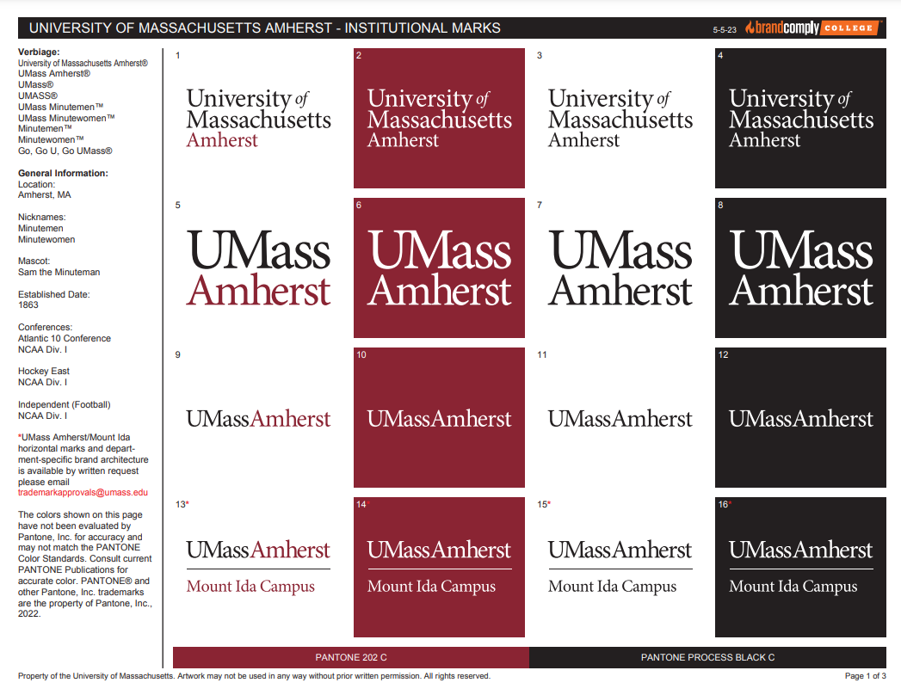
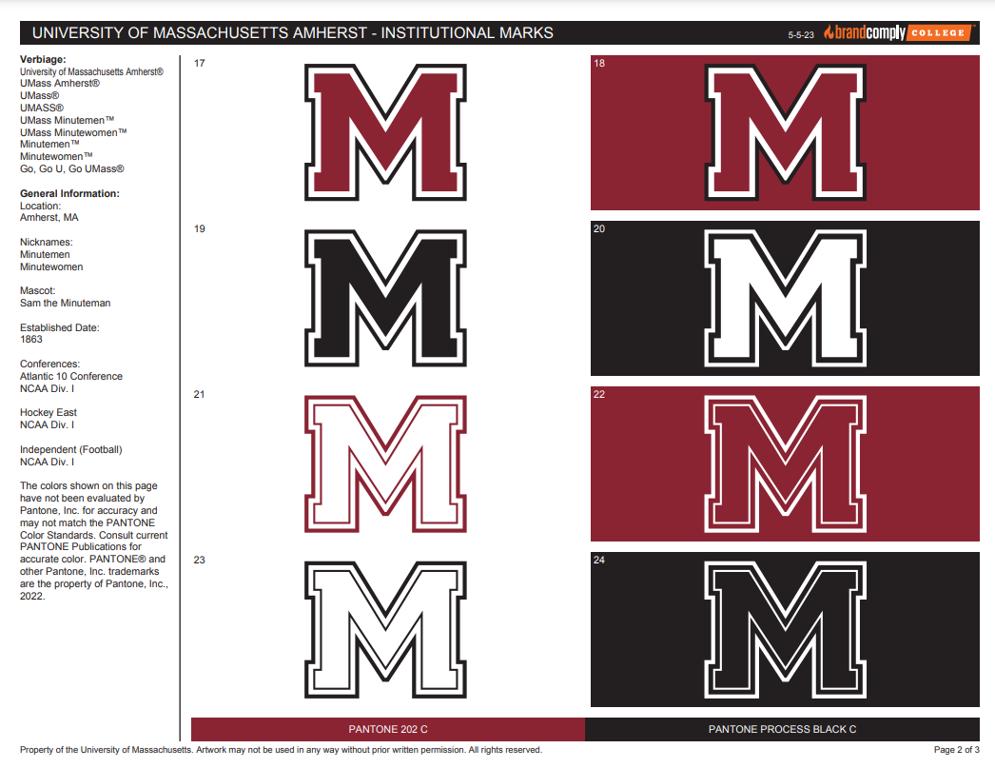
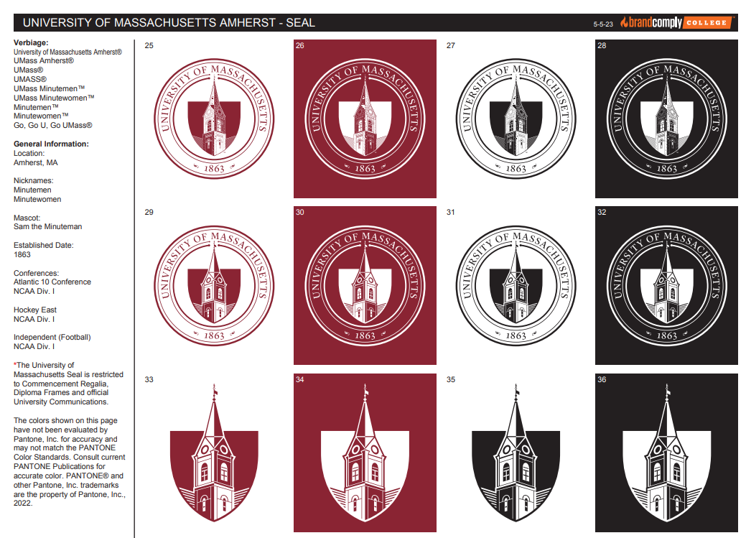

DARTMOUTH


It is the Contractor’s responsibility to contact the Licensing Administration and obtain approval for use of the Licensed Mark listed above. The Licensing Administration can be contacted at trademarkapprovals@umass.edu or (413) 577-8125. Please see the Licensing Administration website at https://www.umass.edu/ae/trademark-licensing-0.
Exhibit a
Use Guidelines

The Licensor’s Trademark Use Guidelines for the Licensed Mark is found at the link below. The Contractor is responsible for remaining familiar with the Use Guidelines which may be amended by the Licensor without notice from time to time.
https://www.umass.edu/ae/sites/default/files/Trustees-Guidelines.pdf

