Men’s Custom Long-Sleeved Chef Coat- White

- Mercer #M60010WH
- Sizes XS-5X. Secchia Institute Logo on left chest; one color. Student first and last name, block style, right chest. Navy Thread
- QTY: 275 each – sizing TBD

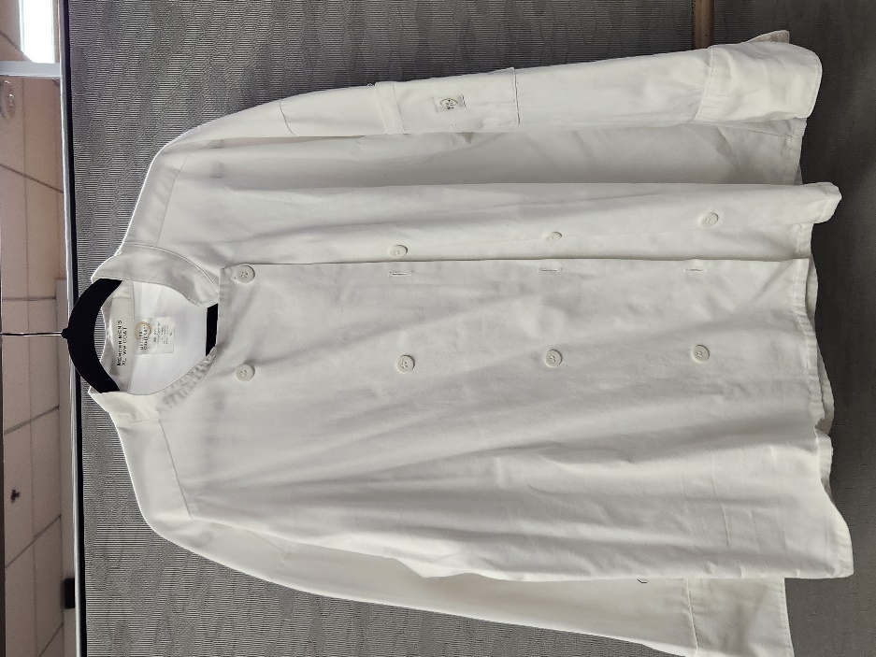
Logo

Name



Ladies Custom Long-Sleeved Coat- White

- Mercer #M60020WH
- Sizes XXS-3X. Secchia Institute Logo on left chest; one color. Student first and last name, block style, right chest. Navy Thread
- QTY: 275 each – sizing TBD

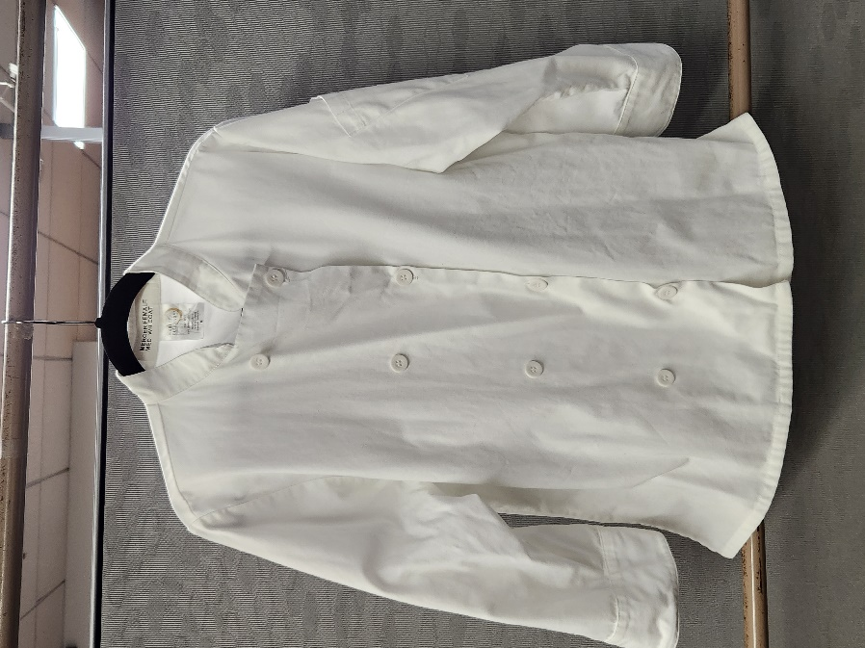
Name
Logo

Men’s Chef Pant
- Uncommon - Item #4001 – Easy-care 65/35 poly cotton twill; 7oz, Yarn-Dyed patterns - Straight leg -2" elastic waist - Brass zipper - Two side pockets - One back pocket
- Sizes XS-6X - pricing to include custom inseam TBD per student.
- QTY: 225 each – sizing TBD

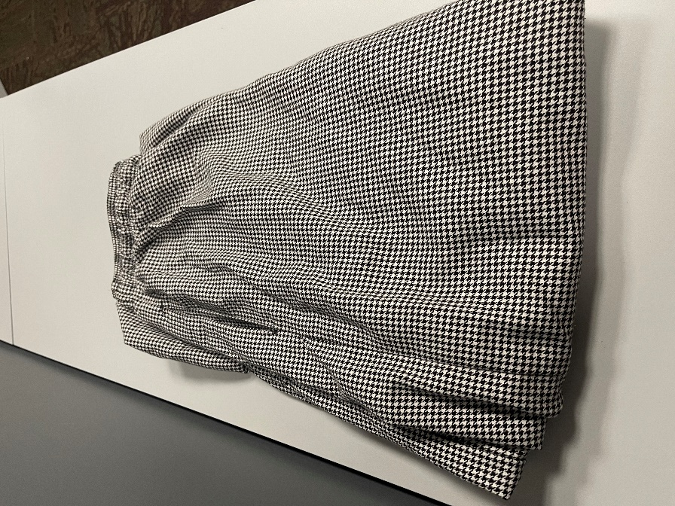

Ladies Chef Pant
- Uncommon – Item #4101 - 65/35 poly cotton twill - Recycled 65/35 poly cotton twill - 7 oz., patterns - Straight leg - 2" elastic waist - Two side pockets - One back pocket - Towel loop - Safety stitched seams - Bar tacked pockets for additional strength
- Sizes XS-6X - pricing to include custom inseam TBD per student.
- QTY: 225 each – sizing TBD

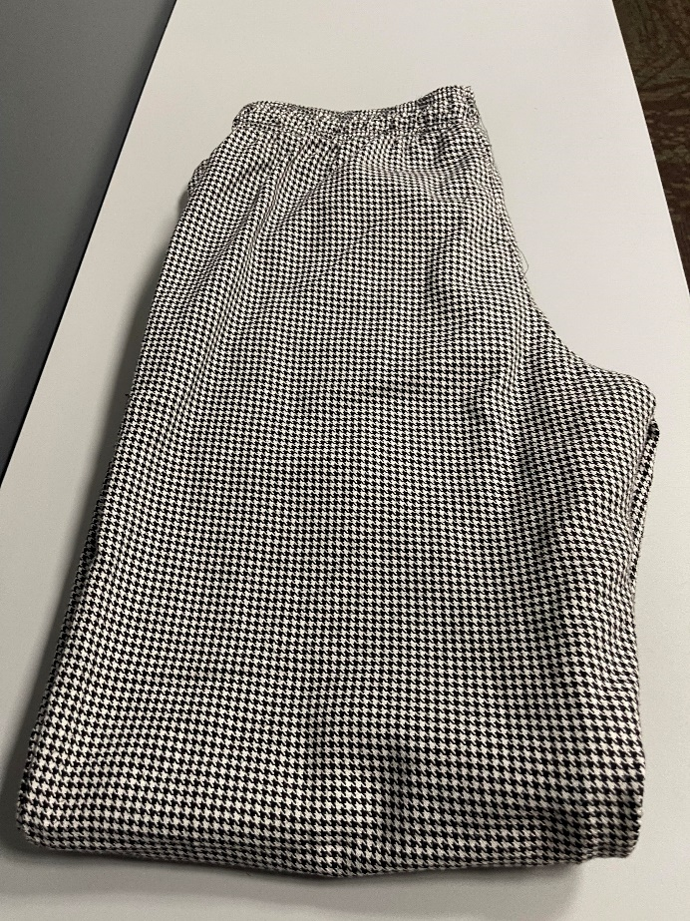

Men’s Long-Sleeved Chef Coat- Black
- Chef Works #BAST-BLK. Poly/cotton blend. Sizes S-4X
- Secchia Institute logo on left chest; Frist name, only, block style, right chest. One color- white thread.
- QTY: 72 each – sizing TBD

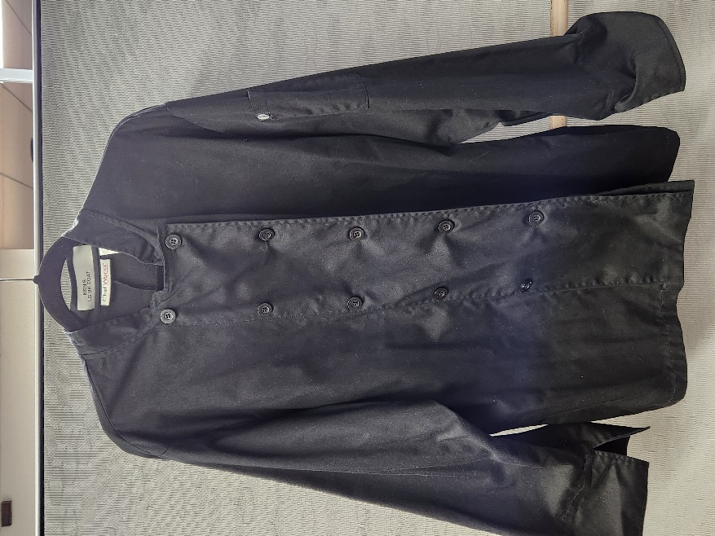
Logo

Name

Ladies Long-Sleeved Chef Coat- Black
- Chef Works #LWLJ-BLK. Poly/cotton blend. Sizes XS-2X
- Secchia Institute logo on left chest; Frist name, only, block style, right chest. One color- white thread.
- QTY: 72 each – sizing TBD

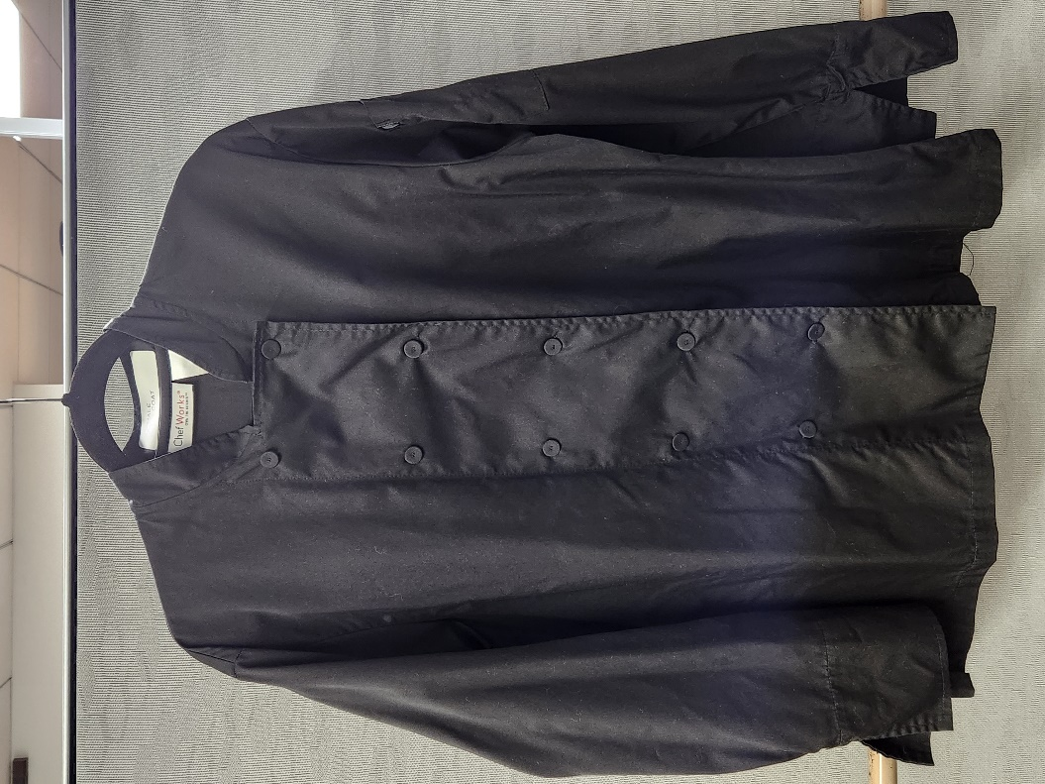
Logo
Name

Women’s Dining Room Pant- Black
- Edwards Item #8793, sizes 0-28W, black pants – pricing to include custom inseam TBD per student.
- QTY: 72 each – sizing TBD

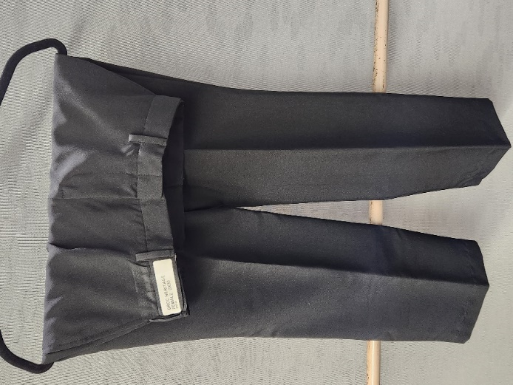

Men’s Dining Room Pant- Black

- Edwards Item #2793, black pant - pricing to include custom inseam TBD per student.
- QTY: 72 each – sizing TBD

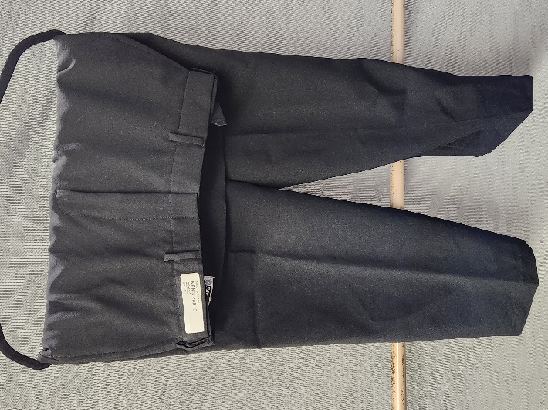

Cook Shirt- Classic Utility
- PinnAcledHD, S302, 100% Spun Polyester, 2 color logo
- QTY: 144 each – sizing TBD

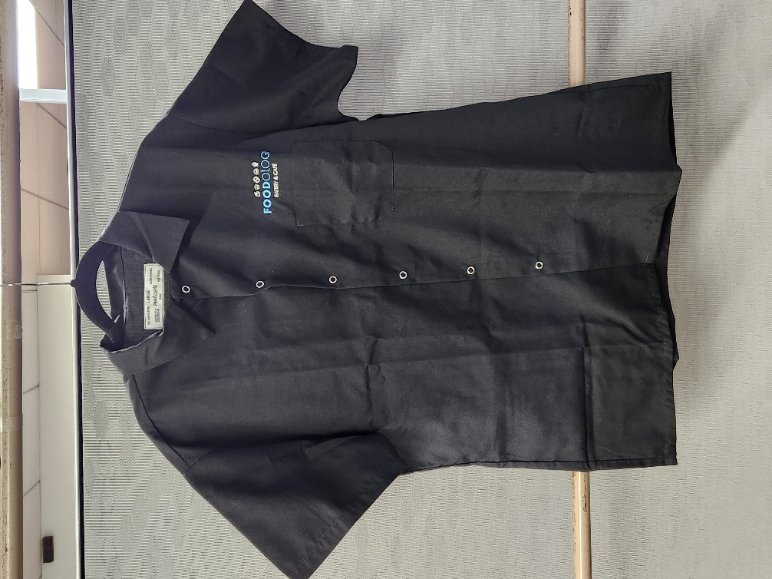



Men’s Industrial Solid Work Shirt Navy
- RED KAP Style #SP24NV – navy, 65/35 poly cotton (4.2 oz. poplin)
- Sizes: XS-6XL
- Price to include Secchia Logo left chest, Fountain Hill Brewery Logo and student’s first name – right chest
- QTY: 36 each – sizing TBD

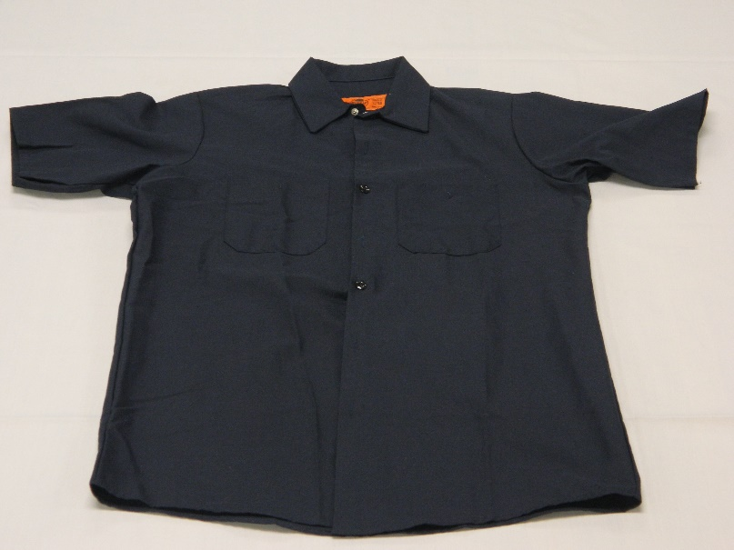
Name
FHB Logo
Logo

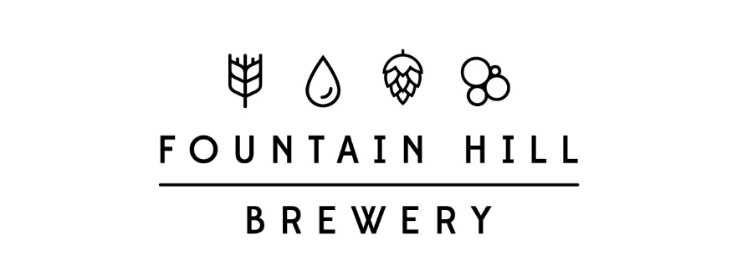

Ladies Industrial Solid Work Shirt Navy
- RED KAP Style #SP23NV – navy, 65/35 poly cotton (4.2 oz. poplin)
- Sizes: XS-4XL
- Price to include Secchia Logo left chest, Fountain Hill Brewery Logo and student’s first name – right chest
- QTY: 36 each – sizing TBD

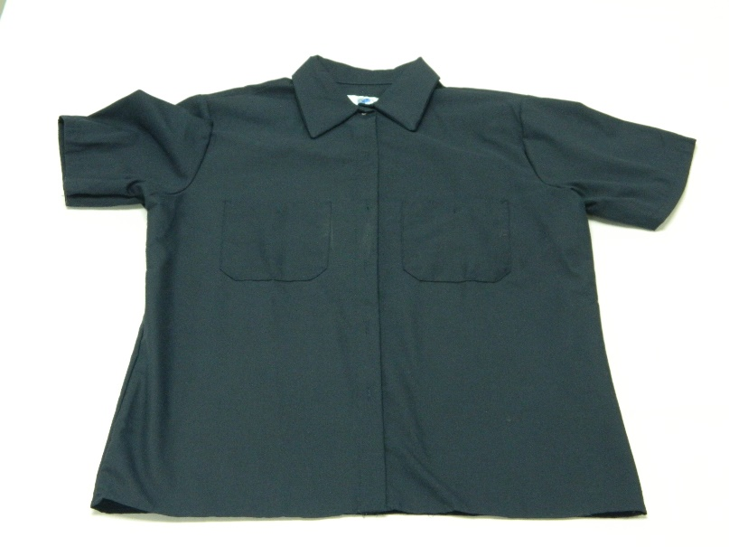
Logo
Name
FHB Logo

Men’s Brew Navy Polo
- Port Authority – Item Number KP155 – Deep Navy - 6.5-ounce, 50/50 double pique knit cotton/poly - Soil-release finish - 1x1 rib knit collar and cuffs - Coverstitched shoulders, armholes and cuffs - 3-button placket with dyed-to-match buttons - Double-needle hem
- Sizes Small-4XL
- Price to include Secchia Logo left chest, Fountain Hill Brewery Logo and student’s first name – right chest
- QTY: 36 each – sizing TBD

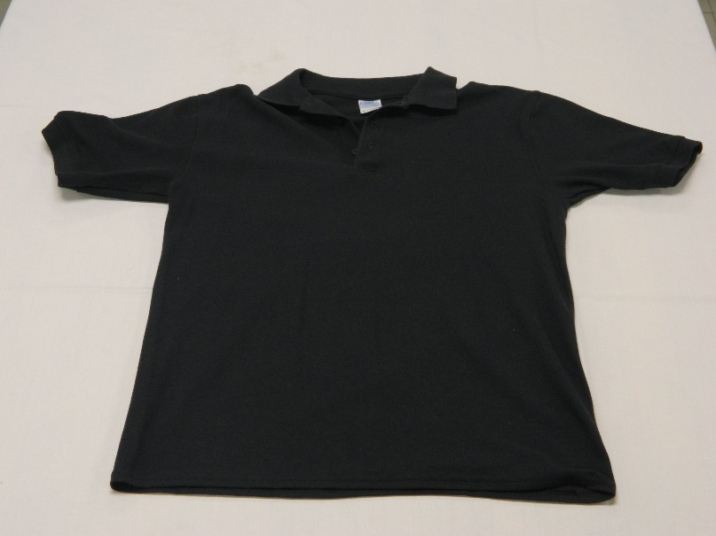
Logo
Name
FHB Logo

Ladies Brew Deep Navy Polo
- Port Authority – Item #LPK155 Deep Navy – 6.5-ounce, 50/50 double pique knit cotton/poly - Soil-release finish - Contoured body for a feminine fit - 1x1 rib knit collar and cuffs - 4-button placket with dyed-to-match buttons – Cover-stitched shoulders, armholes and cuffs - Side seamed - Double-needle hem
- Price to include Secchia Logo left chest, Fountain Hill Brewery Logo and student’s first name – right chest
- Sizes: XS-4XL
- QTY: 36 each – sizing TBD

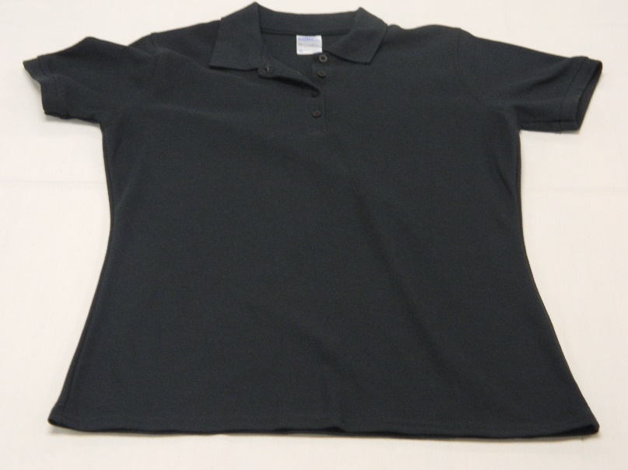
Logo
FHB Logo
Name

